

**online Gas production shop**

**PROJECT**

**Software Design Specification**

– SPRING 2023 –

Record of changeS

|  |  |  |  |
| --- | --- | --- | --- |
| Date | A* M, D | In charge | Change Description |
| 16/05/2023 | A | Đỗ Đức Hiếu, Nhâm Mạnh Hùng, Trần Quang Nam, Nguyễn Hoàng Dương | Add basic functions to Client site |
| 30/05/2023 | A | Đỗ Đức Hiếu, Nhâm Mạnh Hùng, Trần Quang Nam, Nguyễn Hoàng Dương | Add basic functions to Admin site |
| 13/06/2023 | A, M, D | Đỗ Đức Hiếu, Nhâm Mạnh Hùng, Trần Quang Nam, Nguyễn Hoàng Dương | Modify and add Functions and features to Admin site |
| 22/06/2023 | A, M, D | Đỗ Đức Hiếu, Nhâm Mạnh Hùng, Trần Quang Nam, Nguyễn Hoàng Dương | Modify and add Functions and features to Client site |
| 29/06/2023 | M | Đỗ Đức Hiếu, Nhâm Mạnh Hùng, Trần Quang Nam, Nguyễn Hoàng Dương | Complete, summarize functions, planning for future functions and features |
| 13/07/2023 | M, D | Đỗ Đức Hiếu, Nhâm Mạnh Hùng, Trần Quang Nam, Nguyễn Hoàng Dương | Complete project |

*A - Added M - Modified D – Deleted

**Table of Contents**

I. Overview 5

1. Code Packages 5

2. Database Design 6

a. Database Schema 6

b. Table Description 8

II. Code Designs 13

1. Public Customer 13

a. Class Diagram 13

b. Class Specifications 14

c. Sequence Diagram(s) 18

2. Public Admin 22

a. Class Diagram 22

b. Class Specifications 22

c. Sequence Diagram(s) 24

3. Public Order 28

a. Class Diagram 28

b. Class Specifications 29

c. Sequence Diagram(s) 32

4. Public Product 37

a. Class Diagram 37

b. Class Specifications 37

c. Sequence Diagram(s) 41

5. Public News 46

a. Class Diagram 46

b. Class Specifications 47

c. Sequence Diagram(s) 49

6. Public Category 53

a. Class Diagram 53

b. Class Specifications 53

c. Sequence Diagram(s) 55

7. Public Service 56

a. Class Diagram 56

b. Class Specifications 57

c. Sequence Diagram(s) 60

# I. Overview

## 1. Code Packages

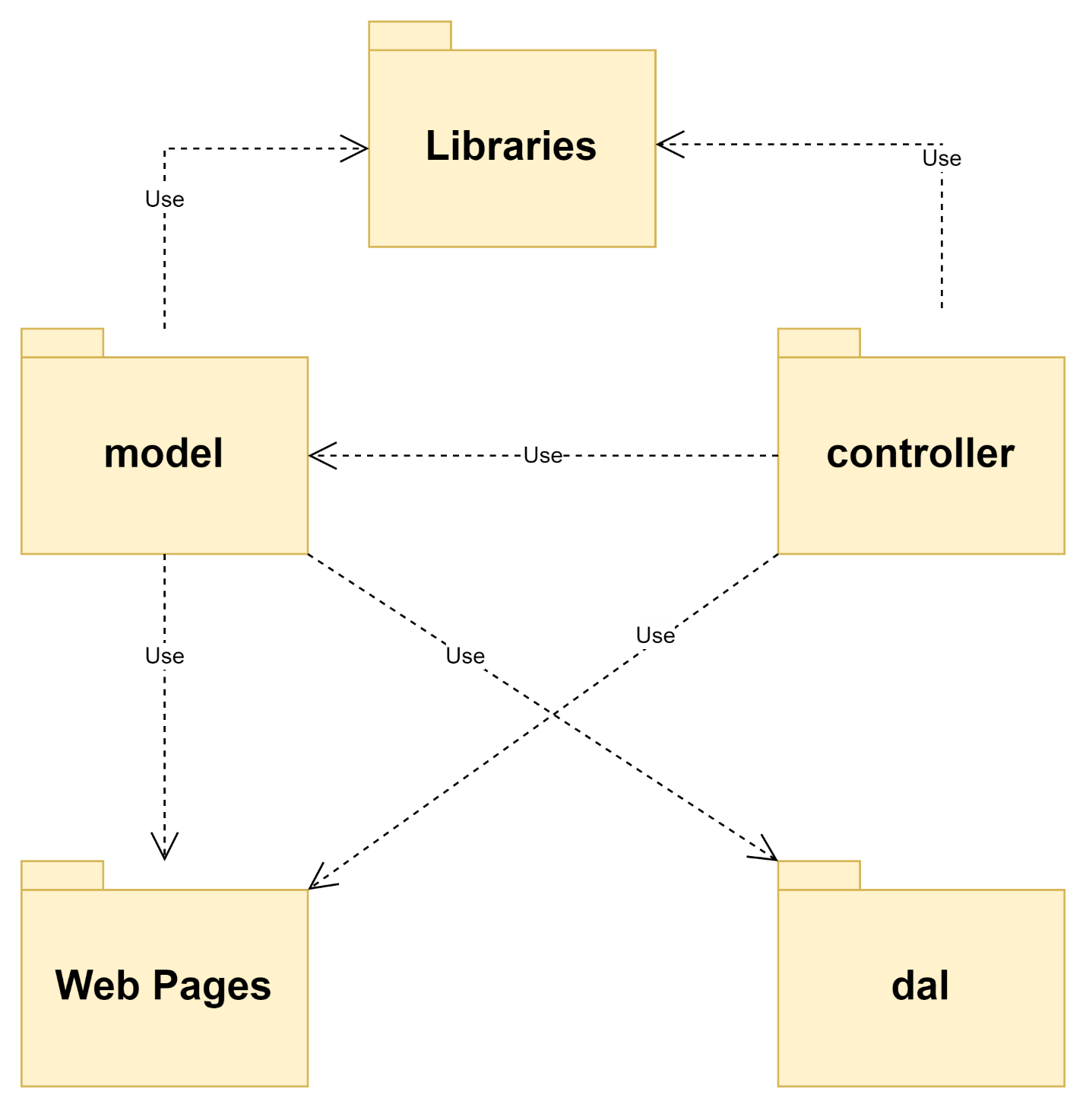

**Figure 1.1.** Code packages diagram

***Package descriptions***

|  |  |  |
| --- | --- | --- |
| **No** | **Package** | **Description** |
| 1 | Libraries | Contains libraries of functions that are needed for coding |
| 2 | model | Contains main entities |
| 3 | controller | Controller package contains APIs, servlet files to process data and show in the website. |
| 4 | dal | Contains file DbContext.java helps connect to the database |
| 5 | Web Pages | Contains screens, GUIs help display content and data to the client |

## 2. Database Design

### a. Database Schema

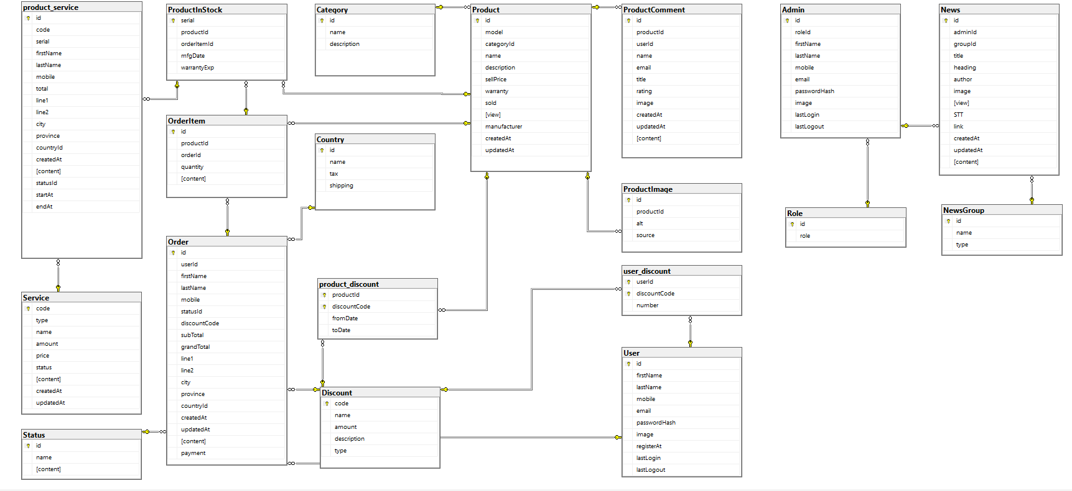

**Figure 1.2.** Database schemas

### b. Table Description

Admin:

|  |  |  |  |  |  |  |  |
| --- | --- | --- | --- | --- | --- | --- | --- |
| **No** | **Field name** | **Type** | **Size** | **Unique** | **Not null** | **PK/ FK** | **Notes** |
| 1 | Id | Bigint |  | x | X | x | PK |
| 2 | roleId | Bigint |  |  | X | x | FK |
| 3 | firstName | Nvarchar | 50 |  | X |  |  |
| 4 | lastName | Nvarchar | 50 |  | X |  |  |
| 5 | Mobile | Navarchar | 15 |  | X |  |  |
| 6 | email | Navarchar | 50 |  | X |  |  |
| 7 | passwordHash | Navarchar | 32 |  | X |  |  |
| 8 | Image | Navarchar | max |  |  |  |  |
| 9 | lastLogin | Datetime |  |  |  |  |  |
| 10 | lastLogout | Datetime |  |  |  |  |  |

Category:

|  |  |  |  |  |  |  |  |
| --- | --- | --- | --- | --- | --- | --- | --- |
| **No** | **Field name** | **Type** | **Size** | **Unique** | **Not null** | **PK/ FK** | **Notes** |
| 1 | Id | int |  | x | x | x | PK |
| 2 | Name | nvarchar | 75 |  | X |  |  |
| 3 | description | nvarchar | max |  |  |  |  |

Customer promotion:

|  |  |  |  |  |  |  |  |
| --- | --- | --- | --- | --- | --- | --- | --- |
| **No** | **Field name** | **Type** | **Size** | **Unique** | **Not null** | **PK/ FK** | **Notes** |
| 1 | PromotionID | bigint |  | x |  | x | PK |
| 2 | CustomerID | bigint |  |  |  |  |  |
| 3 | CouponID | bigint |  |  |  |  |  |

Country:

|  |  |  |  |  |  |  |  |
| --- | --- | --- | --- | --- | --- | --- | --- |
| **No** | **Field name** | **Type** | **Size** | **Unique** | **Not null** | **PK/ FK** | **Notes** |
| 1 | Id | Int |  | x | X | x | PK |
| 2 | Name | nvarchar | 50 |  | x |  |  |
| 3 | Tax | Float |  |  |  |  |  |
| 5 | Shipping | float |  |  |  |  |  |

Discount:

|  |  |  |  |  |  |  |  |
| --- | --- | --- | --- | --- | --- | --- | --- |
| **No** | **Field name** | **Type** | **Size** | **Unique** | **Not null** | **PK/ FK** | **Notes** |
| 1 | Code | Varchar | 15 | x | X | x | PK |
| 2 | Name | Nvarchar | 50 |  |  |  |  |
| 3 | Amount | Float |  |  |  |  |  |
| 4 | Description | nvarchar | Max |  |  |  |  |
| 5 | Type | nvarchar | 20 |  |  |  |  |

News:

|  |  |  |  |  |  |  |  |
| --- | --- | --- | --- | --- | --- | --- | --- |
| **No** | **Field name** | **Type** | **Size** | **Unique** | **Not null** | **PK/ FK** | **Notes** |
| 1 | Id | Bigint |  | x | X | x | PK |
| 2 | AdminId | Bigint | 100 |  |  |  |  |
| 3 | groupId | Bigint |  |  | X | X |  |
| 4 | Title | nvarchar | 100 |  |  |  |  |
| 5 | Heading | Nvarchar | Max |  |  |  |  |
| 6 | Author | nvarchar | 50 |  |  |  |  |
| 7 | Image | Nvarchar | Max |  |  |  |  |
| 8 | view | Bigint |  |  |  |  |  |
| 9 | STT | Bigint |  |  |  |  |  |
| 10 | link | nvarchar | Max |  |  |  |  |
| 11 | createdAt | Datetime |  |  |  |  |  |
| 12 | updatedAt | Datetime |  |  |  |  |  |
| 13 | content | nvarchar | Max |  |  |  |  |

NewsGroup:

|  |  |  |  |  |  |  |  |
| --- | --- | --- | --- | --- | --- | --- | --- |
| **No** | **Field name** | **Type** | **Size** | **Unique** | **Not null** | **PK/ FK** | **Notes** |
| 1 | Id | bigint |  | x | X | X | PK |
| 2 | Name | Nvarchar | 75 |  |  |  |  |
| 3 | type | Nvarchar | 75 |  |  |  |  |

Order:

|  |  |  |  |  |  |  |  |
| --- | --- | --- | --- | --- | --- | --- | --- |
| **No** | **Field name** | **Type** | **Size** | **Unique** | **Not null** | **PK/ FK** | **Notes** |
| 1 | Id | bigInt |  | x | X | X | PK |
| 2 | UserID | Bigint |  |  | X | X | FK |
| 3 | firstName | nvarchar | 50 |  |  |  |  |
| 4 | lastName | nvarchar | 50 |  |  |  |  |
| 5 | Mobile | nvarchar | 15 |  |  |  |  |
| 6 | StatusId | Tinyint |  |  | X | X | FK |
| 7 | discountCode | Nvarchar | 15 |  |  | X | FK |
| 8 | subtotal | Float |  |  | X |  |  |
| 9 | grandTotal | Float |  |  | X |  |  |
| 10 | Line1 | Nvarchar | 50 |  |  |  |  |
| 11 | Line2 | Nvarchar | 50 |  |  |  |  |
| 12 | City | Nvarchar | 50 |  |  |  |  |
| 13 | Province | Nvarchar | 50 |  |  |  |  |
| 14 | countryId | Int |  |  |  | X | FK |
| 15 | createdAt | Datetime |  |  |  |  |  |
| 16 | updatedAt | datetime |  |  |  |  |  |
| 17 | Content | Nvarchar | max |  |  |  |  |
| 18 | Payment | nvarchar | 50 |  |  |  |  |

OrderItem:

|  |  |  |  |  |  |  |  |
| --- | --- | --- | --- | --- | --- | --- | --- |
| **No** | **Field name** | **Type** | **Size** | **Unique** | **Not null** | **PK/ FK** | **Notes** |
| 1 | Id | Bigint |  | x | X | x | PK |
| 2 | ProductId | Bigint | 50 |  | X |  | FK |
| 3 | orderId | Bigint |  |  | X | x | FK |
| 4 | Quantity | int |  |  | X |  |  |
| 5 | Content | nvarchar | Max |  |  |  |  |

Product:

|  |  |  |  |  |  |  |  |
| --- | --- | --- | --- | --- | --- | --- | --- |
| **No** | **Field name** | **Type** | **Size** | **Unique** | **Not null** | **PK/ FK** | **Notes** |
| 1 | Id | bigint |  | x | X | x | PK |
| 2 | Model | nvarchar | 50 |  |  |  |  |
| 3 | categoryId | Int |  |  |  | x | FK |
| 4 | Name | nvarchar | 75 |  | X |  |  |
| 5 | Description | Nvarchar | Max |  |  |  |  |
| 6 | sellPrice | Float |  |  |  |  |  |
| 7 | Warranty | Smallint |  |  |  |  |  |
| 8 | Sold | Bigint |  |  |  |  |  |
| 9 | View | Bigint |  |  |  |  |  |
| 10 | manufacturer | nvarchar | 50 |  |  |  |  |
| 11 | createdAt | Datetime |  |  | x |  |  |
| 12 | updatedAt | datetime |  |  |  |  |  |

Product_discount:

|  |  |  |  |  |  |  |  |
| --- | --- | --- | --- | --- | --- | --- | --- |
| **No** | **Field name** | **Type** | **Size** | **Unique** | **Not null** | **PK/ FK** | **Notes** |
| 1 | ProductId | bigint |  | X | X | X | PK, FK |
| 2 | DiscountCode | varchar | 15 |  | X | X | PK, FK |
| 3 | FromDate | datetime |  |  |  |  |  |
| 4 | ToDate | datetime |  |  |  |  |  |

ProductComment:

|  |  |  |  |  |  |  |  |
| --- | --- | --- | --- | --- | --- | --- | --- |
| **No** | **Field name** | **Type** | **Size** | **Unique** | **Not null** | **PK/ FK** | **Notes** |
| 1 | Id | bigint |  | x | x | x | PK |
| 2 | ProductID | Bigint |  |  | x | x | FK |
| 3 | UserID | Bigint |  |  |  |  |  |
| 4 | Name | nvarchar | 100 |  |  |  |  |
| 5 | Email | nvarchar | 100 |  |  |  |  |
| 6 | Title | nvarchar | 100 |  |  |  |  |
| 7 | Rating | tinyint |  |  | X |  |  |
| 8 | Image | nvarchar | MAX |  |  |  |  |
| 9 | CreatedAt | datetime |  |  | X |  |  |
| 10 | UpdatedAt | datetime |  |  |  |  |  |
| 11 | Content | nvarchar | MAX |  |  |  |  |

ProductImage:

|  |  |  |  |  |  |  |  |
| --- | --- | --- | --- | --- | --- | --- | --- |
| **No** | **Field name** | **Type** | **Size** | **Unique** | **Not null** | **PK/ FK** | **Notes** |
| 1 | Id | bigint |  | x | X | x | PK |
| 2 | ProductId | Bigint |  |  | X | x | FK |
| 3 | Alt | Nvarchar | 100 |  |  |  |  |
| 4 | Source | Nvarchar | MAX |  |  |  |  |

ProductIdStock:

|  |  |  |  |  |  |  |  |
| --- | --- | --- | --- | --- | --- | --- | --- |
| **No** | **Field name** | **Type** | **Size** | **Unique** | **Not null** | **PK/ FK** | **Notes** |
| 1 | Serial | Nvarchar | 50 | x | X | x | PK |
| 2 | ProductId | Bigint |  |  | X | X | FK |
| 3 | orderItemId | Bigint |  |  |  | x | FK |
| 4 | mfgDate | Datetime |  |  |  |  |  |
| 5 | warrantlyExp | datetime |  |  |  |  |  |

Role:

|  |  |  |  |  |  |  |  |
| --- | --- | --- | --- | --- | --- | --- | --- |
| **No** | **Field name** | **Type** | **Size** | **Unique** | **Not null** | **PK/ FK** | **Notes** |
| 1 | Id | Bigint |  | x | X | X | PK |
| 2 | Role | Nvarchar | 50 |  | X |  |  |

Service:

|  |  |  |  |  |  |  |  |
| --- | --- | --- | --- | --- | --- | --- | --- |
| **No** | **Field name** | **Type** | **Size** | **Unique** | **Not null** | **PK/ FK** | **Notes** |
| 1 | Code | nvarchar | 20 | x | X | x | PK |
| 2 | Type | Nvarchar | 75 |  | X |  |  |
| 3 | Name | Nvarchar | 75 |  |  |  |  |
| 4 | Amount | Float |  |  |  |  |  |
| 5 | Price | Float |  |  |  |  |  |
| 6 | Status | Nvarchar | 20 |  |  |  |  |
| 7 | Content | nvarchar | MAX |  |  |  |  |
| 8 | createdAt | Datetime |  |  |  |  |  |
| 9 | updatedAt | Datetime |  |  |  |  |  |

Status:

|  |  |  |  |  |  |  |  |
| --- | --- | --- | --- | --- | --- | --- | --- |
| **No** | **Field name** | **Type** | **Size** | **Unique** | **Not null** | **PK/ FK** | **Notes** |
| 1 | Id | tinyint |  | x | X | x | PK |
| 2 | Name | Nvarchar | 50 |  | X |  |  |
| 3 | content | Nvarchar | MAX |  |  |  |  |

User:

|  |  |  |  |  |  |  |  |
| --- | --- | --- | --- | --- | --- | --- | --- |
| **No** | **Field name** | **Type** | **Size** | **Unique** | **Not null** | **PK/ FK** | **Notes** |
| 1 | Id | bigint |  | x | X | x | PK |
| 2 | FirstName | Nvarchar | 50 |  |  |  |  |
| 3 | LastName | Nvarchar | 50 |  |  |  |  |
| 4 | Mobile | Nvarchar | 15 |  |  |  |  |
| 5 | email | Nvarchar | 50 |  |  |  |  |
| 6 | passwordHash | nvarchar | 32 |  | X |  |  |
| 7 | Image | Nvarchar | MAX |  |  |  |  |
| 8 | registerAt | Datetime |  |  | X |  |  |
| 9 | lastLogin | Datetime |  |  |  |  |  |
| 10 | lastLogout | datetime |  |  |  |  |  |

User_discount:

|  |  |  |  |  |  |  |  |
| --- | --- | --- | --- | --- | --- | --- | --- |
| **No** | **Field name** | **Type** | **Size** | **Unique** | **Not null** | **PK/ FK** | **Notes** |
| 1 | useId | bigint |  | x | X | x | PK, FK |
| 2 | discountCode | varchar | 15 |  | X | x | PK, FK |
| 3 | number | Tinyint |  |  |  |  |  |

# II. Code Designs

## 1. Public Customer

### a. Class Diagram

#### C:\Users\fpt\AppData\Local\Microsoft\Windows\INetCache\Content.MSO\8A5BA6D.tmpClient

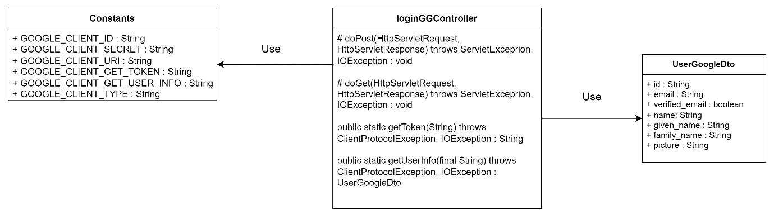

#### C:\Users\fpt\AppData\Local\Microsoft\Windows\INetCache\Content.MSO\81A505C7.tmpAdmin

### b. Class Specifications

#### Client

##### User

|  |  |  |
| --- | --- | --- |
| **No** | **Method** | **Description** |
| 01 | public User getLogin(String, String) | Handle request get account information |
| 02 | public boolean checkExistMobile(String) | Handle request check exist mobile |
| 03 | public boolean checkExistGmailUser(String) | Handle request check exist gmail |
| 04 | public void signUp(String frame, String, String, String, String, String) | Handle request add account to database |
| 05 | public String getEncryptedPassword(String) throws NoSuchAlgorithmException | Handle request hash password |
| 06 | public boolean verifyPassword(String, String) throws NoSuchAlgorithmException | Handle request check password with password in database |
| 07 | public User getUserByMobile(String) | Handle request get account by mobile |
| 08 | public boolean isValidEmail(String) | Handle request check email format |
| 09 | public void updateUserDetail(String, String, String, String, int) | Handle request update account detail |
| 10 | public void updateUserDetailAndPass(String, String, String, String, int, String) | Handle request update account detail and change password |
| 11 | public void updatePass(String, String) | Handle request update password |
| 12 | public User getUserByld(int) | Handle request get account by id |
| 13 | public String convertDateTimeFormat(String) | Handle request convert date |
| 14 | public void updateLastLogin(String,int) | Handle request update last login time |
| 15 | public void updateLastLogOut(String,int) | Handle request update last logout time |

##### loginGGController

|  |  |  |
| --- | --- | --- |
| **No** | **Method** | **Description** |
| 01 | Protected void doPost(HttpServletRequest req, HttpServletResponse resp) throws ServletException, IOException | Handle requests in POST method |
| 02 | Protected void doGet(HttpServletRequest req, HttpServletResponse resp) throws ServletException, IOException | Handle requests in GET method |
| 03 | public static String getToken(String code) throws ClientProtocolException, IOException | Handle encode token |
| 04 | public static UserGoogleDto getUserInfo(final String) throws ClientProtocolException, IOException | Get information from google |

##### userDetailController

|  |  |  |
| --- | --- | --- |
| **No** | **Method** | **Description** |
| 01 | Protected void doPost(HttpServletRequest req, HttpServletResponse resp) throws ServletException, IOException | Handle requests in POST method |
| 02 | Protected void doGet(HttpServletRequest req, HttpServletResponse resp) throws ServletException, IOException | Handle requests in GET method |

##### forgotPasswordController

|  |  |  |
| --- | --- | --- |
| **No** | **Method** | **Description** |
| 01 | Protected void doPost(HttpServletRequest req, HttpServletResponse resp) throws ServletException, IOException | Handle requests in POST method |
| 02 | private String generateVerificationCode() | Handle requests in GET method |

##### signUpController

|  |  |  |
| --- | --- | --- |
| **No** | **Method** | **Description** |
| 01 | Protected void doPost(HttpServletRequest req, HttpServletResponse resp) throws ServletException, IOException | Handle requests in POST method |
| 02 | Protected void doGet(HttpServletRequest req, HttpServletResponse resp) throws ServletException, IOException | Handle requests in GET method |
| 03 | public static int calPage(String, String) | Handle page index |
| 04 | public static boolean isIncludedDigits(String) | Handle input include digit |
| 05 | public static boolean isIncludedLetters(String) | Handle input include letters |
| 06 | public static boolean isIncludedSpecialChars(String) | Handle input include specialChars |

##### changePasswordController

|  |  |  |
| --- | --- | --- |
| **No** | **Method** | **Description** |
| 01 | Protected void doPost(HttpServletRequest req, HttpServletResponse resp) throws ServletException, IOException | Handle requests in POST method |
| 02 | Protected void doGet(HttpServletRequest req, HttpServletResponse resp) throws ServletException, IOException | Handle requests in GET method |
| 03 | public static int calPage(String, String) | Handle page index |
| 04 | public static boolean isIncludedDigits(String) | Handle input include digit |
| 05 | public static boolean isIncludedLetters(String) | Handle input include letters |
| 06 | public static boolean isIncludedSpecialChars(String) | Handle input include specialChars |

##### signInController

|  |  |  |
| --- | --- | --- |
| **No** | **Method** | **Description** |
| 01 | Protected void doPost(HttpServletRequest req, HttpServletResponse resp) throws ServletException, IOException | Handle requests in POST method |
| 02 | Protected void doGet(HttpServletRequest req, HttpServletResponse resp) throws ServletException, IOException | Handle requests in GET method |

##### signOutController

|  |  |  |
| --- | --- | --- |
| **No** | **Method** | **Description** |
| 01 | Protected void doPost(HttpServletRequest req, HttpServletResponse resp) throws ServletException, IOException | Handle requests in POST method |
| 02 | Protected void doGet(HttpServletRequest req, HttpServletResponse resp) throws ServletException, IOException | Handle requests in GET method |

##### loginGGController

|  |  |  |
| --- | --- | --- |
| **No** | **Method** | **Description** |
| 01 | Protected void doPost(HttpServletRequest req, HttpServletResponse resp) throws ServletException, IOException | Handle requests in POST method |
| 02 | Protected void doGet(HttpServletRequest req, HttpServletResponse resp) throws ServletException, IOException | Handle requests in GET method |
| 03 | public static String getToken(String code) throws ClientProtocolException, IOException | Handle encode token |
| 04 | public static UserGoogleDto getUserInfo(final String) throws ClientProtocolException, IOException | Get information from google |

#### Admin

##### Customer

|  |  |  |
| --- | --- | --- |
| **No** | **Method** | **Description** |
| 01 | public List getListCountry() | Handle request get list countries |
| 02 | public void getOrderItem(int, int) | Handle request update total when applying tax and shipping |
| 03 | public void updateRecent(int, String) | Handle request apply recent delivery addresses to current order |
| 04 | public Boolean applyDiscount(int, String) | Handle request apply discount to current order |
| 05 | public void getCart(int) | Handle request get orders in cart |
| 06 | public void getOrderDetail(int) | Handle request get detail information of an order |
| 07 | public List getListOrder(int) | Handle request list of orders |
| 08 | public void checkout(int, String[]) | Handle request checkout an order |
| 09 | public void getCheckoutDetail(int) | Handle request get detail information of a checkout |
| 10 | public List getAddressList(int) | Handle request list of delivery addresses |
| 11 | public void placeOrder(int, String, String, String, String, String, String, String, String,  String) | Handle request place an order |
| 12 | public void dropOrder(int, int) | Handle request cancel an order before making purchase |
| 13 | public void cancelOrder(int) | Handle request cancel an order after making purchase |

##### userManageController

|  |  |  |
| --- | --- | --- |
| **No** | **Method** | **Description** |
| 01 | Protected void doPost(HttpServletRequest req, HttpServletResponse resp) throws ServletException, IOException | Handle requests in POST method |
| 02 | Protected void doGet(HttpServletRequest req, HttpServletResponse resp) throws ServletException, IOException | Handle requests in GET method |

##### homeController

|  |  |  |
| --- | --- | --- |
| **No** | **Method** | **Description** |
| 01 | Protected void doPost(HttpServletRequest req, HttpServletResponse resp) throws ServletException, IOException | Handle requests in POST method |
| 02 | Protected void doGet(HttpServletRequest req, HttpServletResponse resp) throws ServletException, IOException | Handle requests in GET method |

### c. Sequence Diagram(s)

#### Client

##### Sign in with password

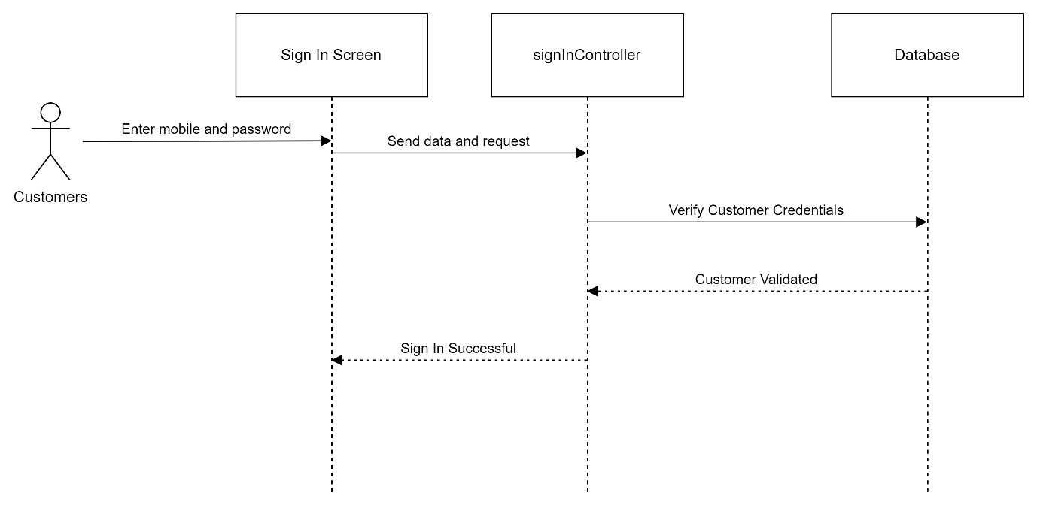

##### Sign up with password

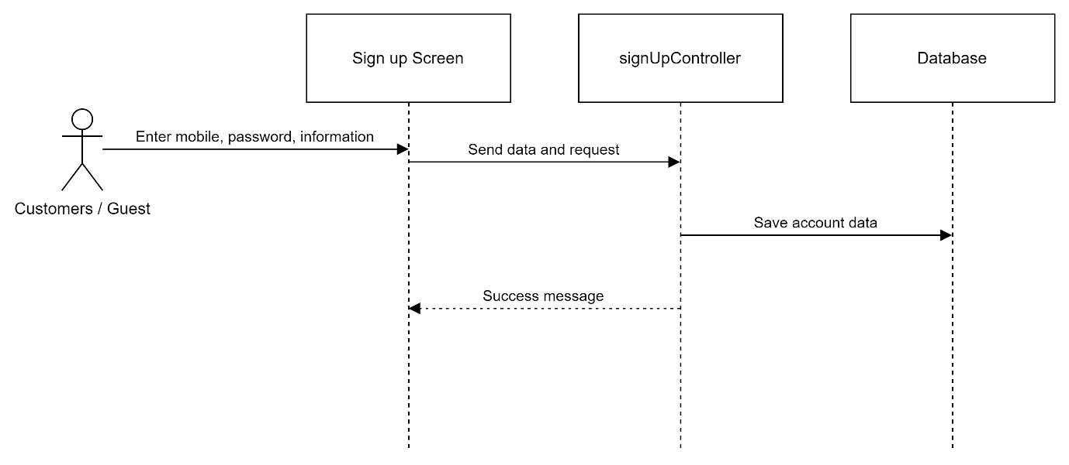

##### Sign out

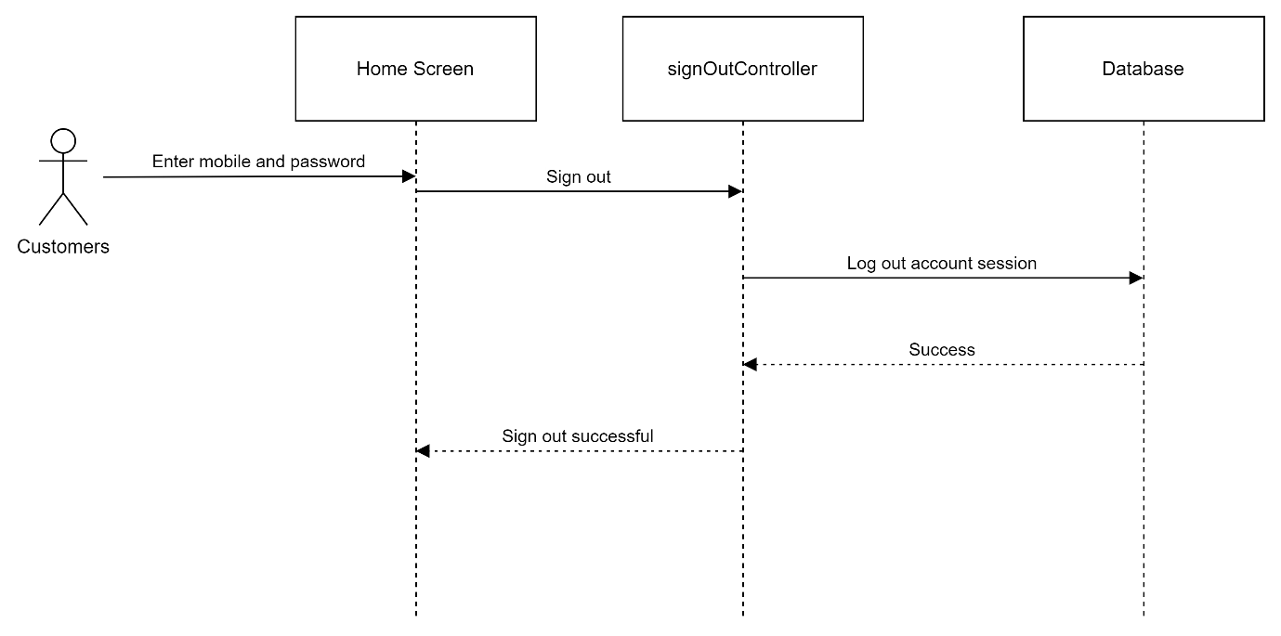

##### Forgot password

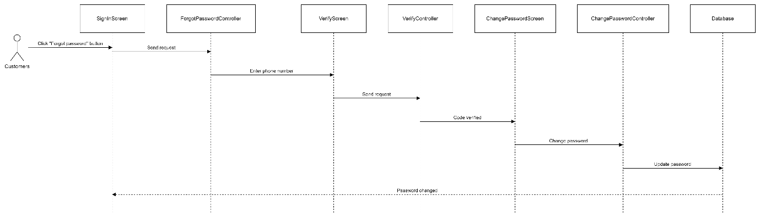

##### Change password

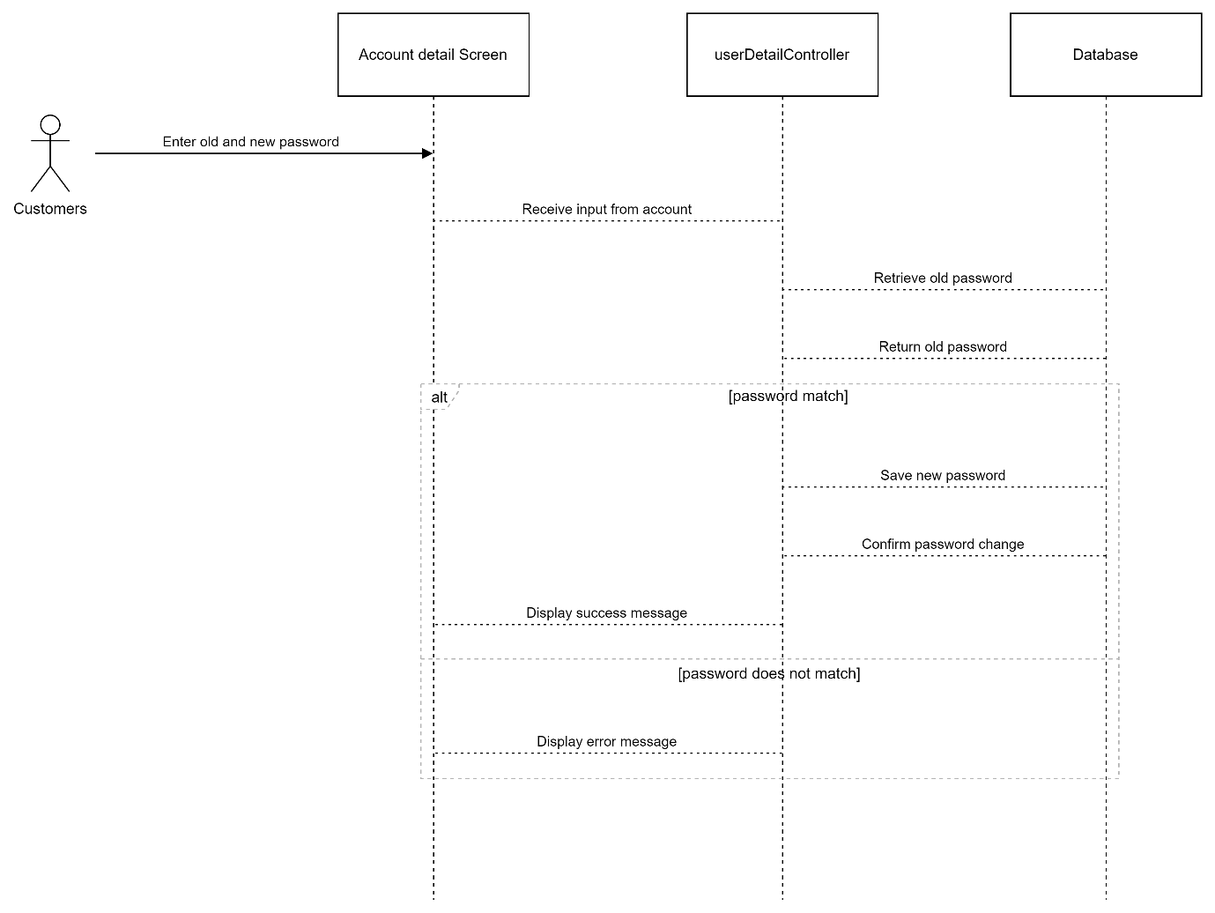

##### Update account detail

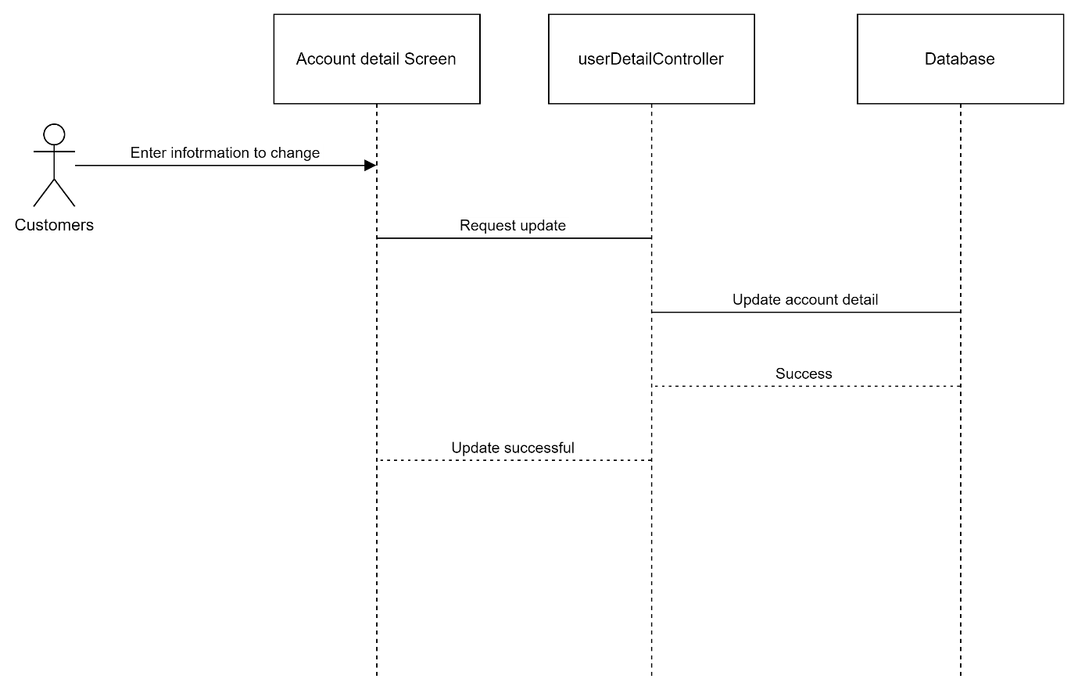

##### **Sign in or Sign Up with GG**

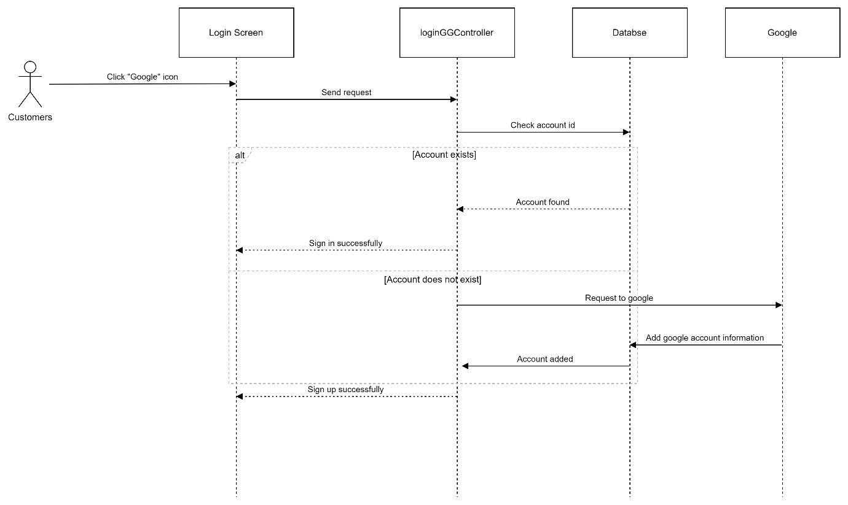

## 2. Public Admin

### C:\Users\fpt\AppData\Local\Microsoft\Windows\INetCache\Content.MSO\63003C42.tmpa. Class Diagram

### b. Class Specifications

#### Admin

|  |  |  |
| --- | --- | --- |
| **No** | **Method** | **Description** |
| 01 | Public String convertDateTimeFormat(String) | Handle request convert date |
| 02 | public Admin getAdminByMobile(String) | Handle request get account by mobile |
| 03 | public List<Admin> getListRole() | Handle request get list role |
| 04 | public String getRoleByld(int) | Handle request get role by id |
| 05 | public int getEndPage(filterBy) | Handle request get total page |
| 06 | public int getEndPageResearch(String) | Handle request get total page while searching |
| 07 | public List<Admin> getListStaff(int, String) | Handle request get list staff |
| 08 | public String getEncryptedPassword(String) throws NoSuchAlgorithmException | Handle request hash password |
| 09 | public boolean verifyPassword(String, String) throws NoSuchAlgorithmException | Handle request check password with password in database |
| 10 | public void updateLastLogin(String,int) | Handle request update last login time |
| 11 | public void updateLastLogOut(String,int) | Handle request update last logout time |
| 12 | public void deleteAdmin(int) | Handle request delete account |
| 13 | public void updatePass(String, String) | Handle request update password |
| 14 | public void updateRole(int,int) | Handle request update role |
| 15 | public void addStaff (int, String, String, String, String, String) | Handle request add staff |

##### VerifyNumController

|  |  |  |
| --- | --- | --- |
| **No** | **Method** | **Description** |
| 01 | Protected void doPost(HttpServletRequest req, HttpServletResponse resp) throws ServletException, IOException | Handle requests in POST method |
| 02 | Protected void doGet(HttpServletRequest req, HttpServletResponse resp) throws ServletException, IOException | Handle requests in GET method |
| 03 | private String generateVerificationCode() | Handle generate verify code |

##### infoManageController

|  |  |  |
| --- | --- | --- |
| **No** | **Method** | **Description** |
| 01 | Protected void doPost(HttpServletRequest req, HttpServletResponse resp) throws ServletException, IOException | Handle requests in POST method |
| 02 | Protected void doGet(HttpServletRequest req, HttpServletResponse resp) throws ServletException, IOException | Handle requests in GET method |

##### changePasswordController

|  |  |  |
| --- | --- | --- |
| **No** | **Method** | **Description** |
| 01 | Protected void doPost(HttpServletRequest req, HttpServletResponse resp) throws ServletException, IOException | Handle requests in POST method |
| 02 | Protected void doGet(HttpServletRequest req, HttpServletResponse resp) throws ServletException, IOException | Handle requests in GET method |
| 03 | public static int calPage(String, String) | Handle page index |
| 04 | public static boolean isIncludedDigits(String) | Handle input include digit |
| 05 | public static boolean isIncludedLetters(String) | Handle input include letters |
| 06 | public static boolean isIncludedSpecialChars(String) | Handle input include specialChars |

##### signInController

|  |  |  |
| --- | --- | --- |
| **No** | **Method** | **Description** |
| 01 | Protected void doPost(HttpServletRequest req, HttpServletResponse resp) throws ServletException, IOException | Handle requests in POST method |
| 02 | Protected void doGet(HttpServletRequest req, HttpServletResponse resp) throws ServletException, IOException | Handle requests in GET method |

##### staffController

|  |  |  |
| --- | --- | --- |
| **No** | **Method** | **Description** |
| 01 | Protected void doPost(HttpServletRequest req, HttpServletResponse resp) throws ServletException, IOException | Handle requests in POST method |
| 02 | Protected void doGet(HttpServletRequest req, HttpServletResponse resp) throws ServletException, IOException | Handle requests in GET method |
| 03 | public static int calPage(String, String) | Handle page idnex |
| 04 | public static boolean isIncludedDigits(String) | Handle input include digit |
| 05 | public static boolean isIncludedLetters(String) | Handle input include letters |
| 06 | public static boolean isIncludedSpecialChars(String) | Handle input include specialChars |

##### signOutController

|  |  |  |
| --- | --- | --- |
| **No** | **Method** | **Description** |
| 01 | Protected void doPost(HttpServletRequest req, HttpServletResponse resp) throws ServletException, IOException | Handle requests in POST method |
| 02 | Protected void doGet(HttpServletRequest req, HttpServletResponse resp) throws ServletException, IOException | Handle requests in GET method |

### c. Sequence Diagram(s)

#### Admin

##### Sign in with password

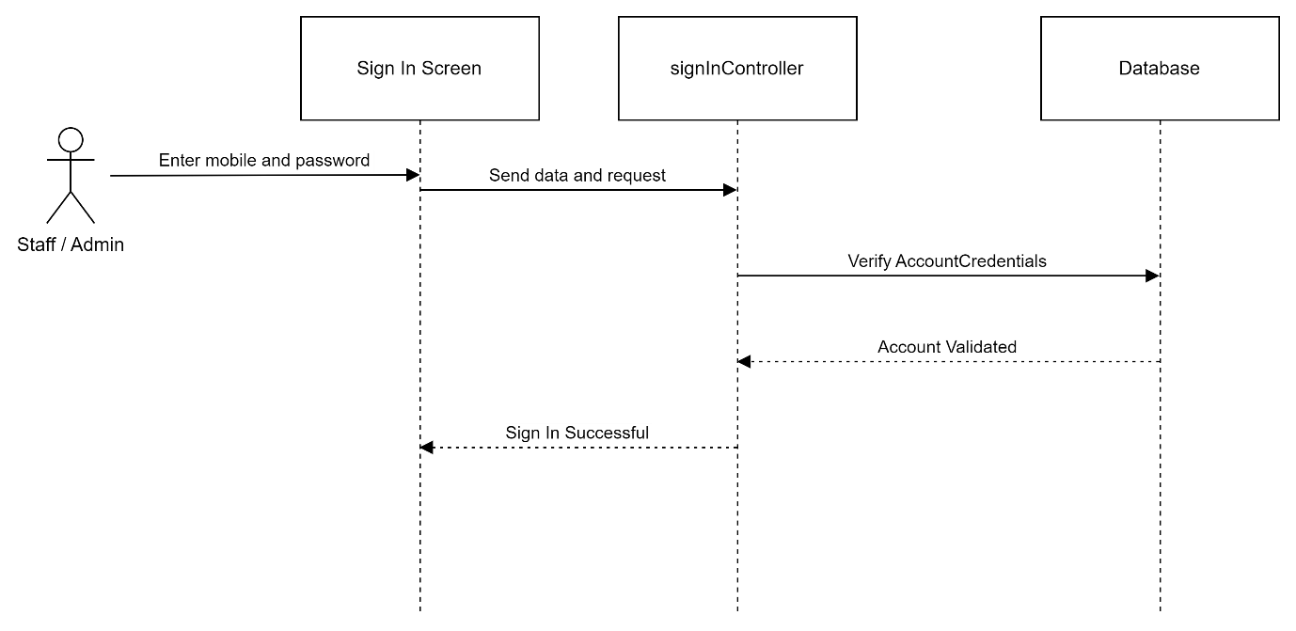

##### Sign out

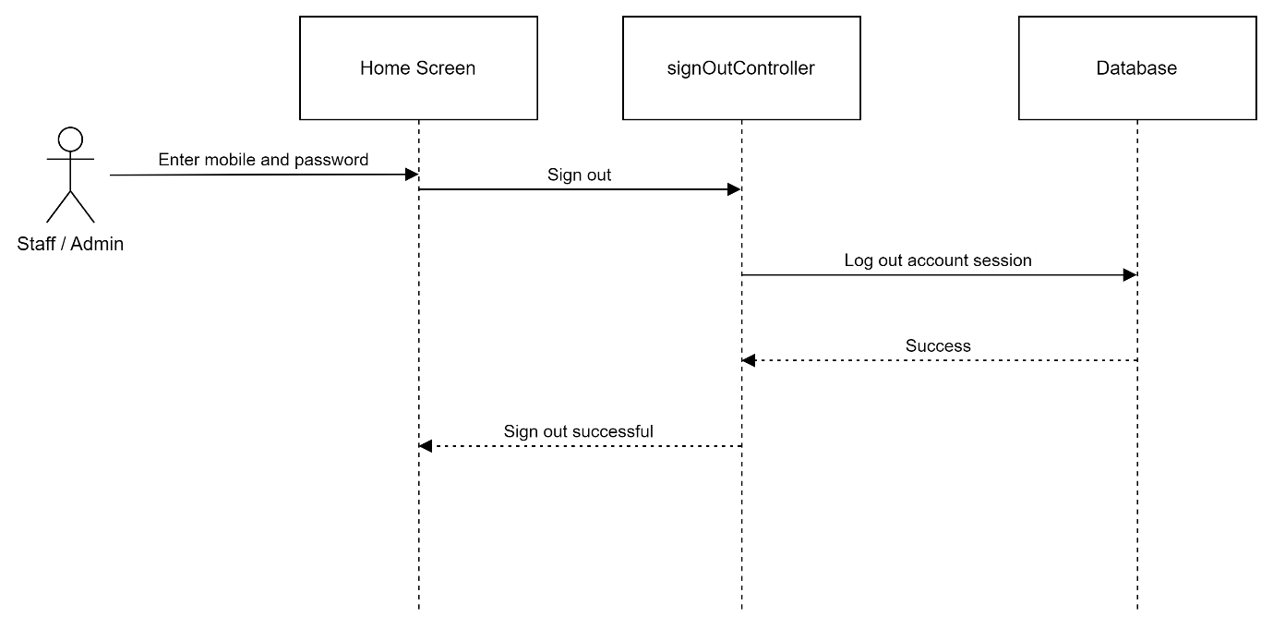

##### Forgot password

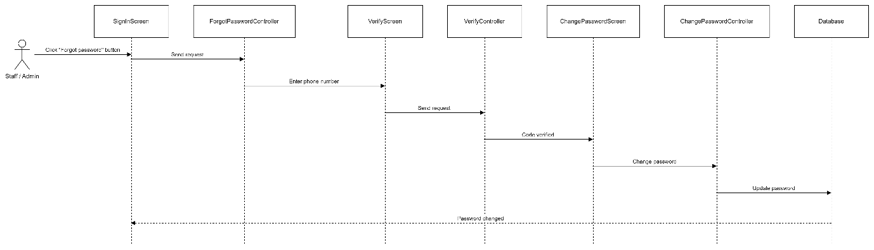

##### Change password

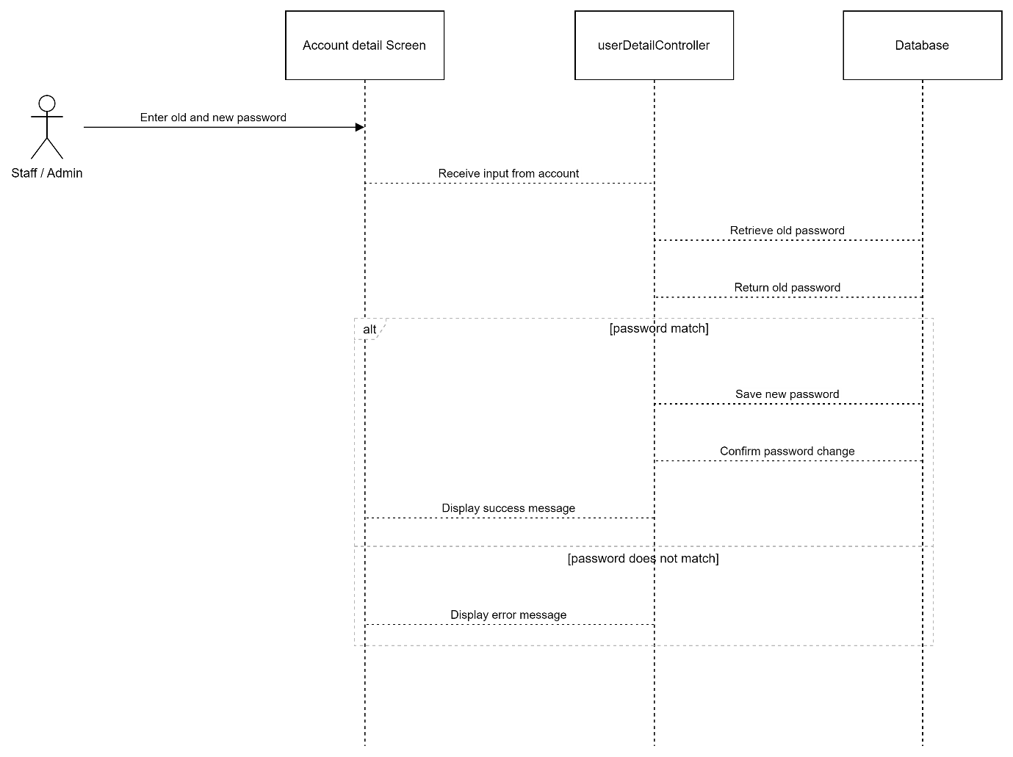

##### Update account detail

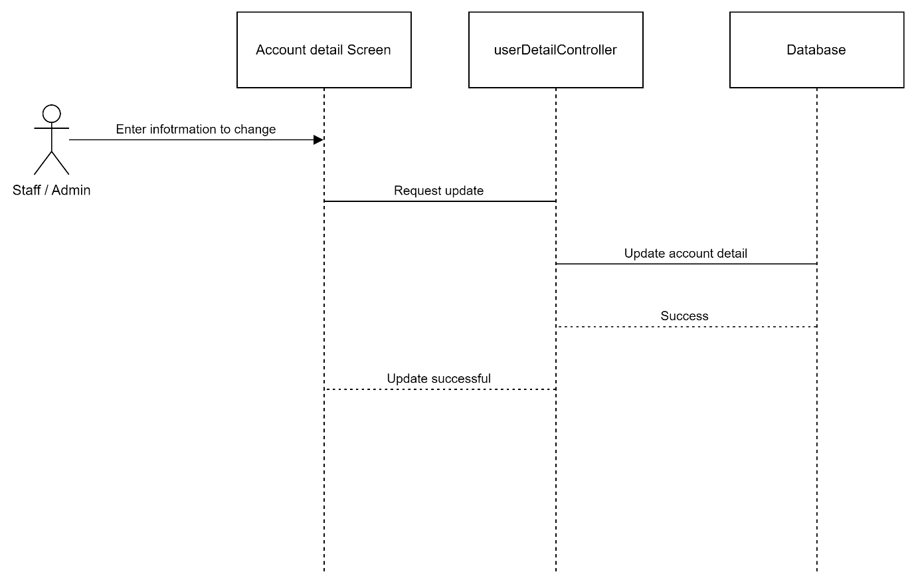

##### Create staff account

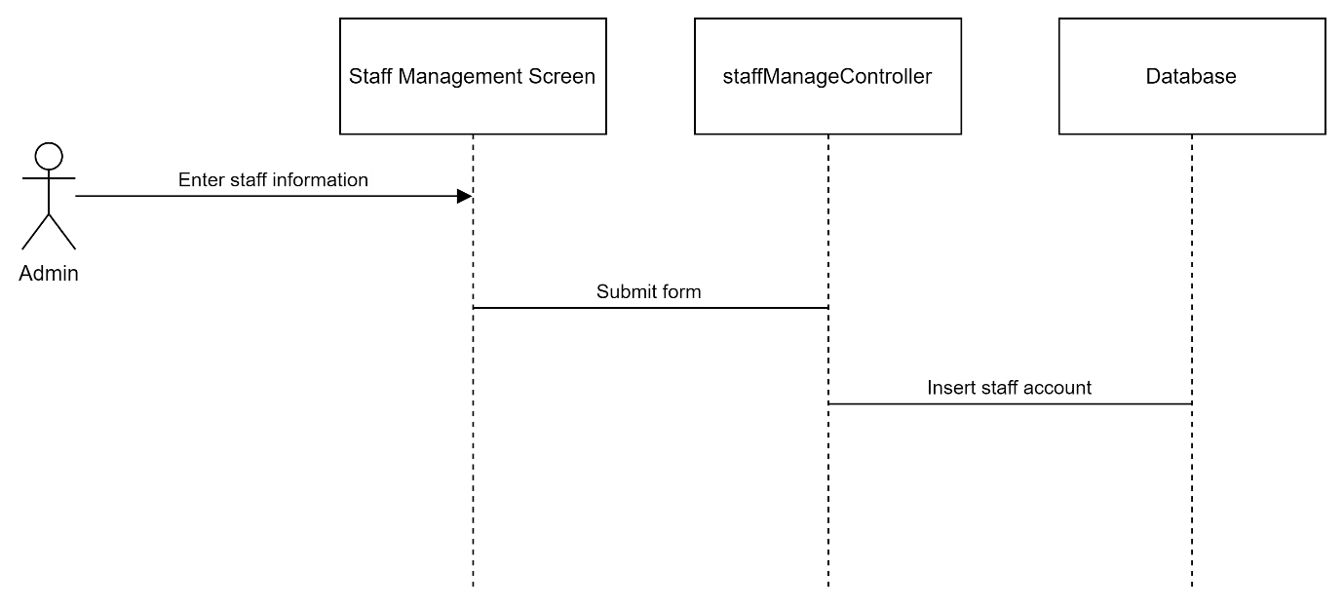

##### View list customer account

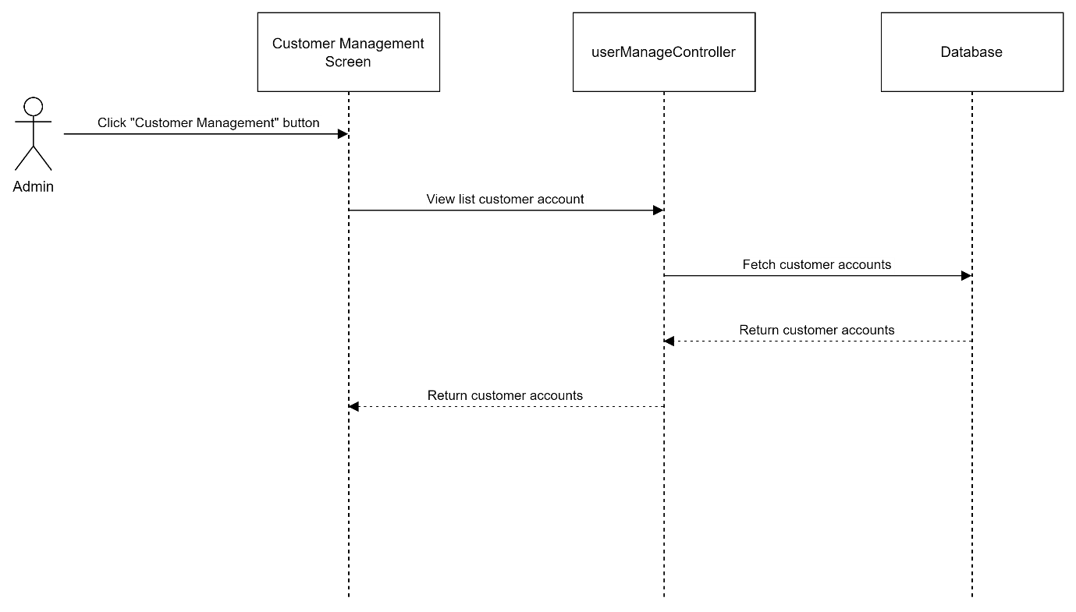

## 3. Public Order

### a. Class Diagram

#### C:\Users\Dell\AppData\Local\Microsoft\Windows\INetCache\Content.MSO\E207ACA3.tmpClient

#### Admin

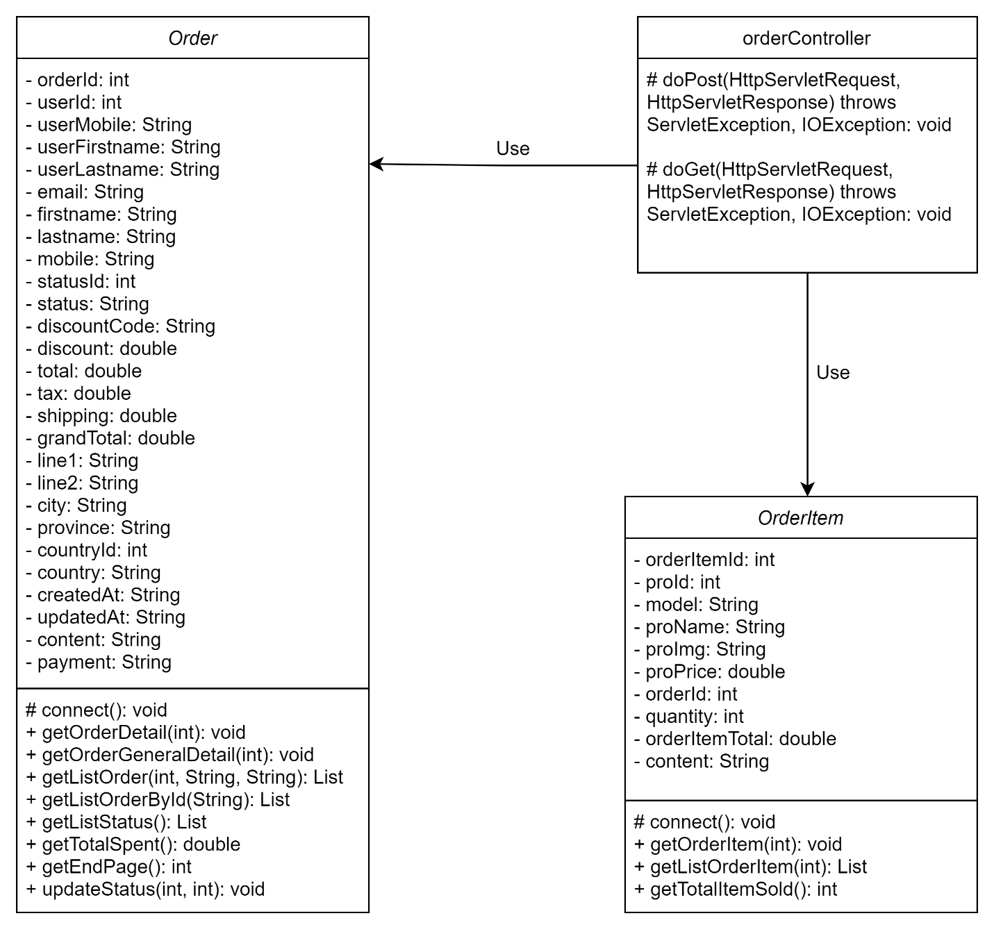

### b. Class Specifications

#### Client

##### Order

|  |  |  |
| --- | --- | --- |
| **No** | **Method** | **Description** |
| 01 | public List getListCountry() | Handle request get list countries |
| 02 | public void getOrderItem(int, int) | Handle request update total when applying tax and shipping |
| 03 | public void updateRecent(int, String) | Handle request apply recent delivery addresses to current order |
| 04 | public Boolean applyDiscount(int, String) | Handle request apply discount to current order |
| 05 | public void getCart(int) | Handle request get orders in cart |
| 06 | public void getOrderDetail(int) | Handle request get detail information of an order |
| 07 | public List getListOrder(int) | Handle request list of orders |
| 08 | public void checkout(int, String[]) | Handle request checkout an order |
| 09 | public void getCheckoutDetail(int) | Handle request get detail information of a checkout |
| 10 | public List getAddressList(int) | Handle request list of delivery addresses |
| 11 | public void placeOrder(int, String, String, String, String, String, String, String, String,  String) | Handle request place an order |
| 12 | public void dropOrder(int, int) | Handle request cancel an order before making purchase |
| 13 | public void cancelOrder(int) | Handle request cancel an order after making purchase |

##### OrderItem

|  |  |  |
| --- | --- | --- |
| **No** | **Method** | **Description** |
| 01 | public List getListOrderItem(int) | Handle request get list order items |
| 02 | public void getOrderItem(int) | Handle request get detail of a order item |
| 03 | public void updateRecent(int, String) | Handle request apply recent delivery addresses to current order |
| 04 | public void addOrderItem(int, int, int) | Handle request add products into cart |
| 05 | public void deleteSingleOrderItem(int) | Handle request delete a single kind of product from cart |
| 06 | public void deleteOrderItems String[]) | Handle request delete many kinds of products from cart |

##### Config

|  |  |  |
| --- | --- | --- |
| **No** | **Method** | **Description** |
| 01 | public static String md5(String) | Handle request digest a string by md5 algorithm |
| 02 | public static String Sha256(String) | Handle request digest a string by sha256 algorithm |
| 03 | public static String hashAllFields(Map) | Handle request hash input fields |
| 04 | public static String hmacSHA512(final String, final String) | Handle request digest a string by hmacSHA512 algorithm |
| 05 | public static String getIpAddress(HttpServletRequest) | Handle request get IP address of request |
| 06 | public static String getRandomNumber(int) | Handle request generate random string numbers |

##### orderController

|  |  |  |
| --- | --- | --- |
| **No** | **Method** | **Description** |
| 01 | Protected void doPost(HttpServletRequest req, HttpServletResponse resp) throws ServletException, IOException | Handle requests in POST method |
| 02 | Protected void doGet(HttpServletRequest req, HttpServletResponse resp) throws ServletException, IOException | Handle requests in GET method |

##### vnpayController

|  |  |  |
| --- | --- | --- |
| **No** | **Method** | **Description** |
| 01 | Protected void doPost(HttpServletRequest req, HttpServletResponse resp) throws ServletException, IOException | Handle requests in POST method |

#### Admin

##### Order

|  |  |  |
| --- | --- | --- |
| **No** | **Method** | **Description** |
| 01 | public void getOrderDetail(int) | Handle request get detail information of an order |
| 02 | public void getOrderGeneralDetail(int) | Handle request get general information of an order |
| 03 | public List getListOrder(int, String, String) | Handle request get list of orders |
| 04 | public List getListOrderById(String) | Handle request get list of orders by ID |
| 05 | public List getListStatus() | Handle request get list of statuses |
| 06 | public double getTotalSpent() | Handle request get total earning |
| 07 | public int getEndPage() | Handle request get last page when dividing list of orders into pages |
| 08 | public void updateStatus(in, int) | Handle request update status of a request |

##### OrderItem

|  |  |  |
| --- | --- | --- |
| **No** | **Method** | **Description** |
| 01 | public List getListOrderItem(int) | Handle request get list order items |
| 02 | public void getOrderItem(int) | Handle request get detail of a order item |
| 03 | public int getTotalItemSold() | Handle request get total number of items sold |

##### orderController

|  |  |  |
| --- | --- | --- |
| **No** | **Method** | **Description** |
| 01 | Protected void doPost(HttpServletRequest req, HttpServletResponse resp) throws ServletException, IOException | Handle requests in POST method |
| 02 | Protected void doGet(HttpServletRequest req, HttpServletResponse resp) throws ServletException, IOException | Handle requests in GET method |

### c. Sequence Diagram(s)

#### Client

##### C:\Users\Dell\AppData\Local\Microsoft\Windows\INetCache\Content.MSO\A9EB279B.tmpAdd to cart

##### Delete from cart

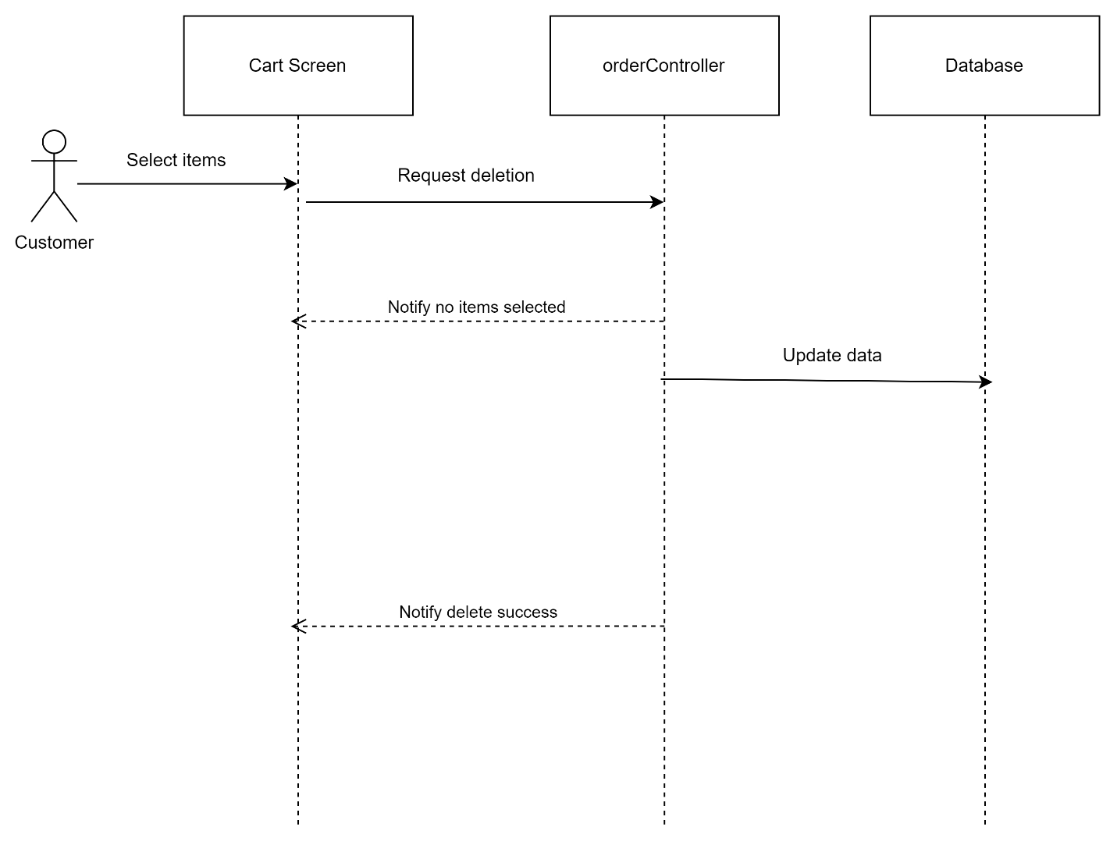

##### Place order

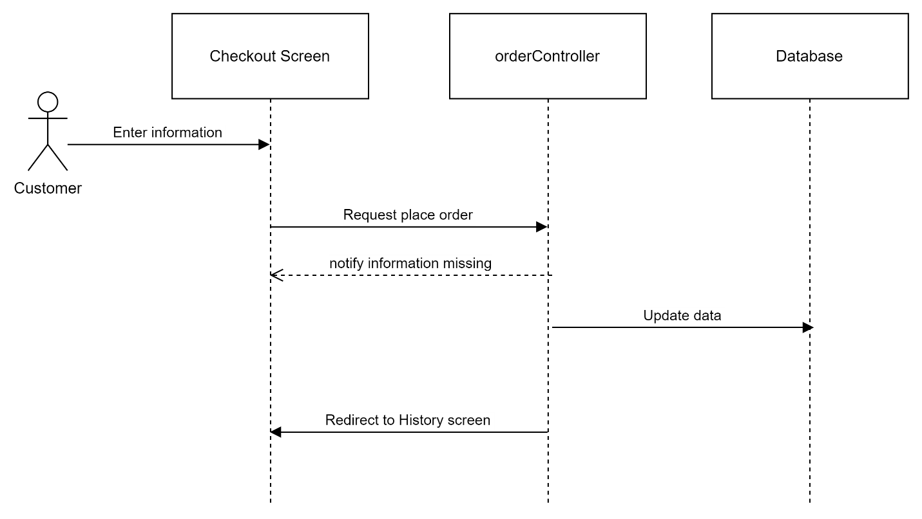

##### C:\Users\Dell\AppData\Local\Microsoft\Windows\INetCache\Content.MSO\ABD7EBE2.tmpPlace order with VNPAY Sandbox

##### View order history

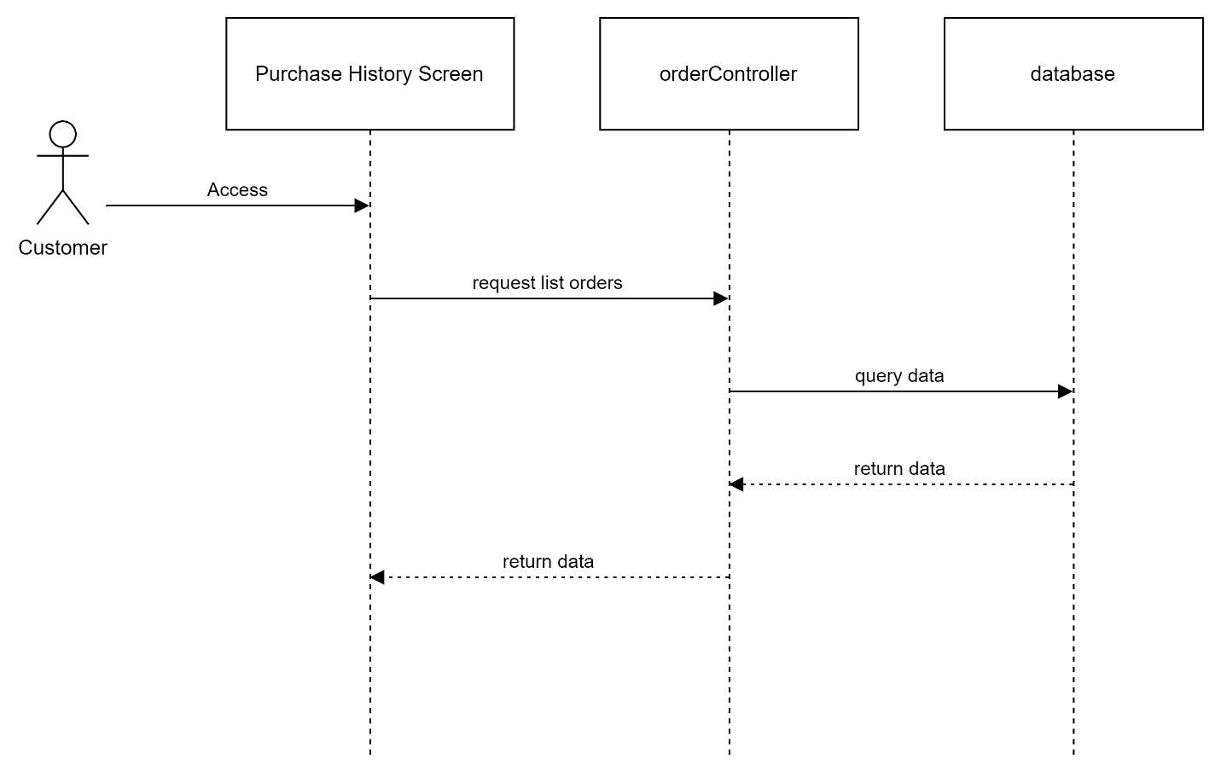

##### View order detail

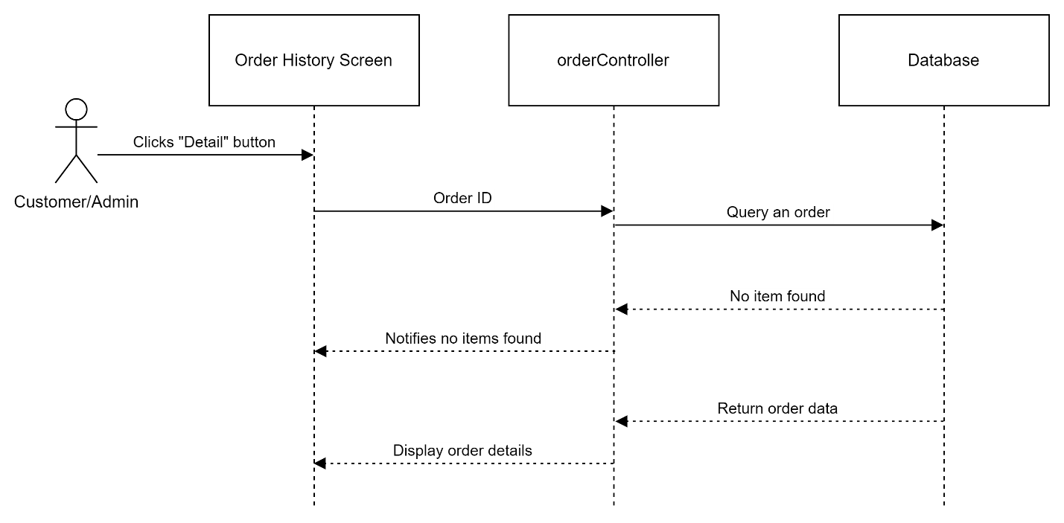

#### Admin

##### View list orders

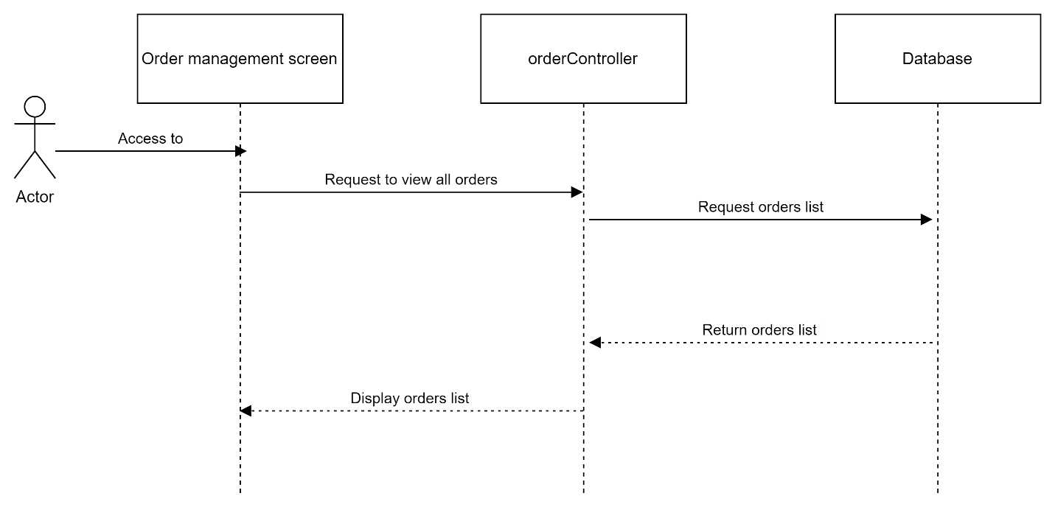

##### Search order

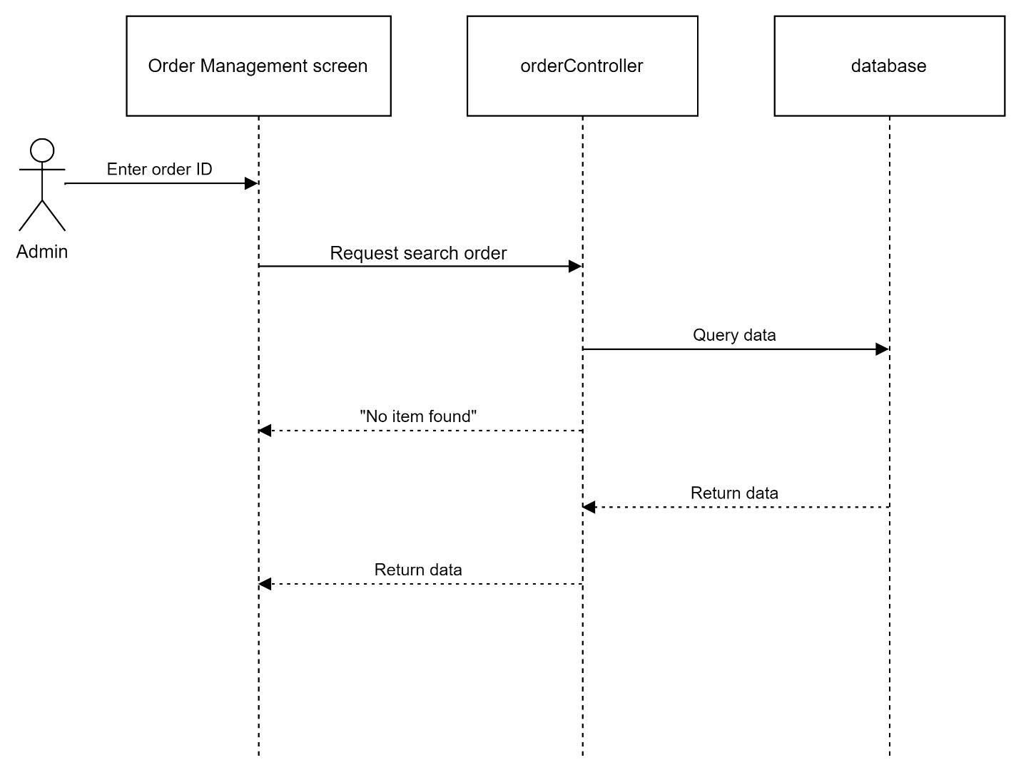

## 4. Public Product

### a. Class Diagram

#### Client

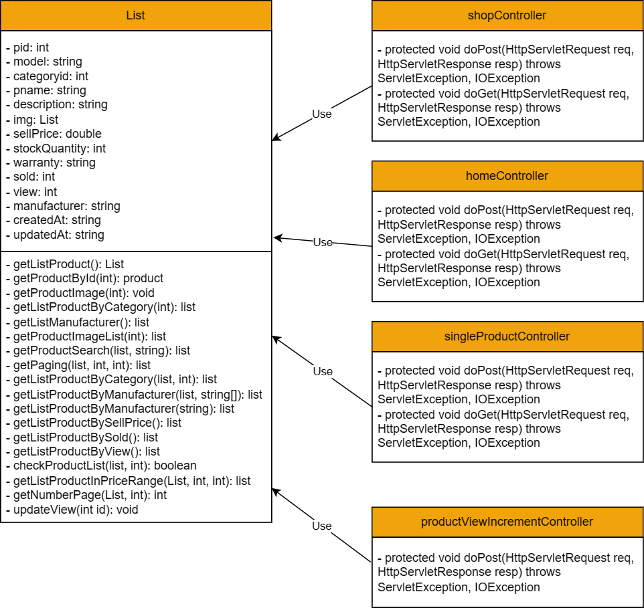

### b. Class Specifications

#### Client

##### Product

|  |  |  |
| --- | --- | --- |
| **No** | **Method** | **Description** |
| 01 | public List<Product> getListProduct() | Handle request get list product |
| 02 | public boolean checkProductList(List<Product> list, int pid) | Handle request check a product available in the list |
| 03 | public Product getProductById(int id); | Handle request get product by Id |
| 04 | public void getProductImage(int productId) | Handle request set status deactive a product |
| 05 | public List<Product> getListProductByCategory(int cid) | Handle request get list product by category for shop page and admin page |
| 06 | public List<String> getListManufacturer() | Handle request get list product manufacturer |
| 07 | public List<String> getProductImageList(int pid) | Handle request get list images of product |
| 08 | public List<Product> getProductSearch(List<Product> data, String substring) | Handle request search a product |
| 09 | public List<Product> getPaging(List<Product> data, int index, int numberDisplay) | Handle request paging of products |
| 10 | public List<Product> getListProductByCategory(List<Product> data, int cid) | Handle request get list product by category for filter |
| 11 | public List<Product> getListProductByManufacturer(List<Product> data, String[] manufacturer) | Handle request get list product by manufacturer for filter |
| 12 | public List<Product> getListProductByManufacturer(String manu) | Handle request get list product by manufacturer for shop |
| 13 | public List<Product> getListProductBySellPrice() | Handle request get list product by sell price ascending for shop |
| 14 | public List<Product> getListProductBySold() | Handle request get list product by sold descending for shop |
| 15 | public List<Product> getListProductByView() | Handle request get list product by view descending for shop |
| 16 | public List<Product> getListProductInPriceRange(List<Product> data, int min, int max) | Handle request get list products in price range |
| 17 | public int getNumberPage(List<Product> data, int numberDisplay) | Handle request get number of page for paging products |
| 18 | public void updateView(int id) | Handle request increment number of views in product by Id |

##### homeController

|  |  |  |
| --- | --- | --- |
| **No** | **Method** | **Description** |
| 01 | Protected void doPost(HttpServletRequest req, HttpServletResponse resp) throws ServletException, IOException | Handle requests in POST method |
| 02 | Protected void doGet(HttpServletRequest req, HttpServletResponse resp) throws ServletException, IOException | Handle requests in GET method |

##### shopController

|  |  |  |
| --- | --- | --- |
| **No** | **Method** | **Description** |
| 01 | Protected void doPost(HttpServletRequest req, HttpServletResponse resp) throws ServletException, IOException | Handle requests in POST method |
| 02 | Protected void doGet(HttpServletRequest req, HttpServletResponse resp) throws ServletException, IOException | Handle requests in GET method |

##### singleProductController

|  |  |  |
| --- | --- | --- |
| **No** | **Method** | **Description** |
| 01 | Protected void doPost(HttpServletRequest req, HttpServletResponse resp) throws ServletException, IOException | Handle requests in POST method |
| 02 | Protected void doGet(HttpServletRequest req, HttpServletResponse resp) throws ServletException, IOException | Handle requests in GET method |

##### productViewIncrementController

|  |  |  |
| --- | --- | --- |
| **No** | **Method** | **Description** |
| 01 | Protected void doPost(HttpServletRequest req, HttpServletResponse resp) throws ServletException, IOException | Handle requests in POST method |

##### productManageController

|  |  |  |
| --- | --- | --- |
| **No** | **Method** | **Description** |
| 01 | Protected void doPost(HttpServletRequest req, HttpServletResponse resp) throws ServletException, IOException | Handle requests in POST method |
| 02 | Protected void doGet(HttpServletRequest req, HttpServletResponse resp) throws ServletException, IOException | Handle requests in GET method |

##### productDetailManageController

|  |  |  |
| --- | --- | --- |
| **No** | **Method** | **Description** |
| 01 | Protected void doPost(HttpServletRequest req, HttpServletResponse resp) throws ServletException, IOException | Handle requests in POST method |
| 02 | Protected void doGet(HttpServletRequest req, HttpServletResponse resp) throws ServletException, IOException | Handle requests in GET method |

#### Admin

##### Product

|  |  |  |
| --- | --- | --- |
| **No** | **Method** | **Description** |
| 01 | public List<Product> getListProduct() | Handle request get list product |
| 02 | public boolean checkProductList(List<Product> list, int pid) | Handle request check a product available in the list |
| 03 | public void deleteProduct(int pid) | Handle request delete a product |
| 04 | public void addProduct(Product p); | Handle request add a product |
| 05 | public Product getProductById(int id); | Handle request get product by Id |
| 06 | public void updateProduct(); | Handle request update product |
| 07 | public void getProductImage(int productId) | Handle request set status deactive a product |
| 08 | public List<Product> getListProductByCategory(int cid) | Handle request get list product by category for shop page and admin page |
| 09 | public List<String> getListManufacturer() | Handle request get list product manufacturer |
| 10 | public void deleteProductImage(int pid) | Handle request delete product images |
| 11 | public List<String> getProductImageList(int pid) | Handle request get list images of product |
| 12 | public List<Product> getProductSearch(List<Product> data, String substring) | Handle request search a product |
| 13 | public List<Product> getPaging(List<Product> data, int index, int numberDisplay) | Handle request paging of products |
| 14 | public void deleteProductInStock() | Handle request delete product in stock |
| 15 | public List<Product> getListProductByCategory(List<Product> data, int cid) | Handle request get list product by category for filter |
| 16 | public List<Product> getListProductByManufacturer(String manu) | Handle request get list product by manufacturer for shop |
| 17 | public int getNumberPage(List<Product> data, int numberDisplay) | Handle request get number of page for paging products |

##### productManageController

|  |  |  |
| --- | --- | --- |
| **No** | **Method** | **Description** |
| 01 | Protected void doPost(HttpServletRequest req, HttpServletResponse resp) throws ServletException, IOException | Handle requests in POST method |
| 02 | Protected void doGet(HttpServletRequest req, HttpServletResponse resp) throws ServletException, IOException | Handle requests in GET method |

##### productDetailManageController

|  |  |  |
| --- | --- | --- |
| **No** | **Method** | **Description** |
| 01 | Protected void doPost(HttpServletRequest req, HttpServletResponse resp) throws ServletException, IOException | Handle requests in POST method |
| 02 | Protected void doGet(HttpServletRequest req, HttpServletResponse resp) throws ServletException, IOException | Handle requests in GET method |

### c. Sequence Diagram(s)

#### Client

##### View product detail

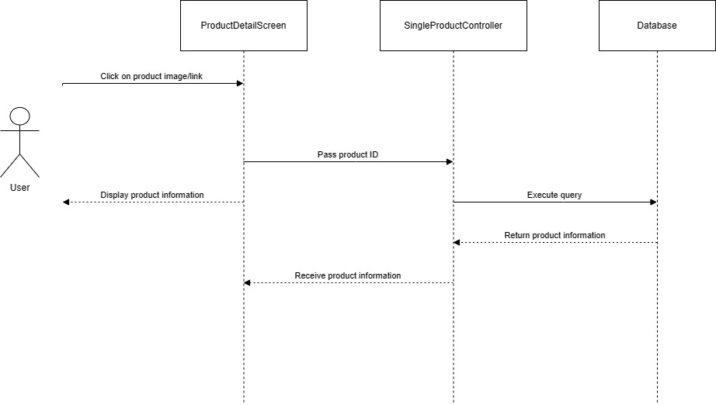

##### View shop page

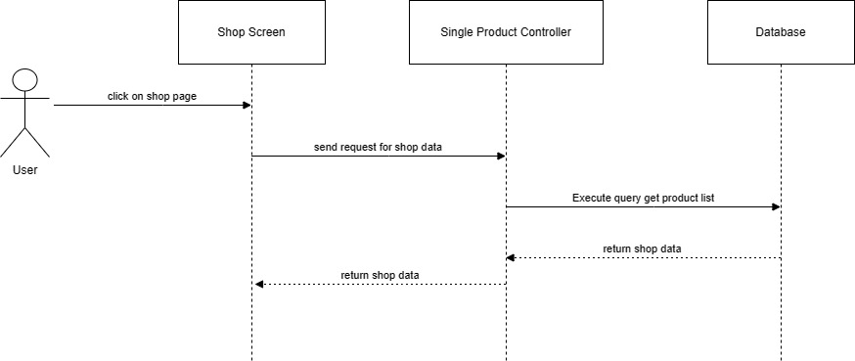

##### View all product by Category/Manufacturer

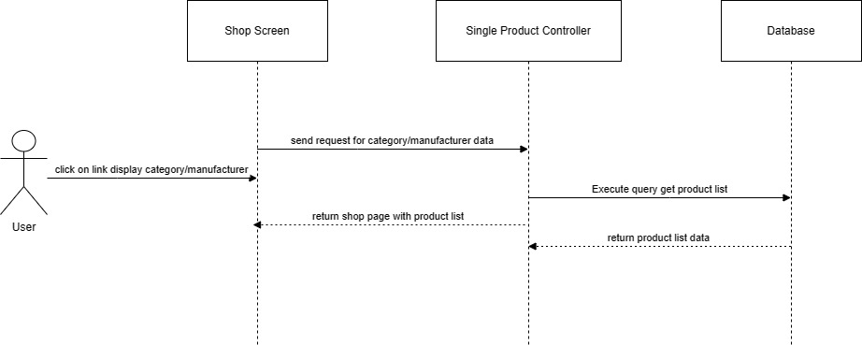

##### Search Product

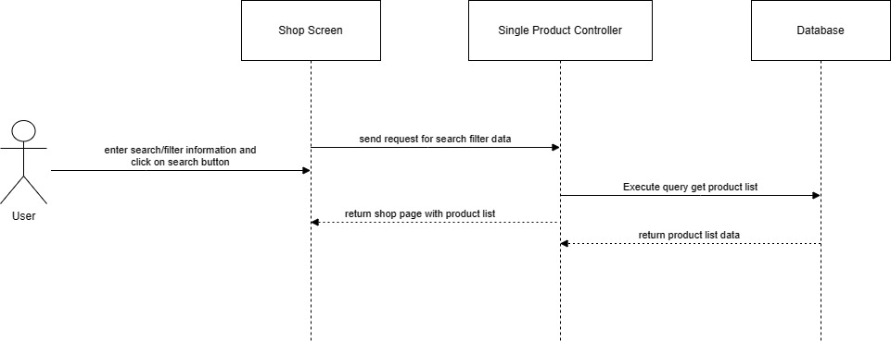

##### View all product by Category/Manufacturer



##### Search/Filter Product (Client)



#### Admin

##### View all product

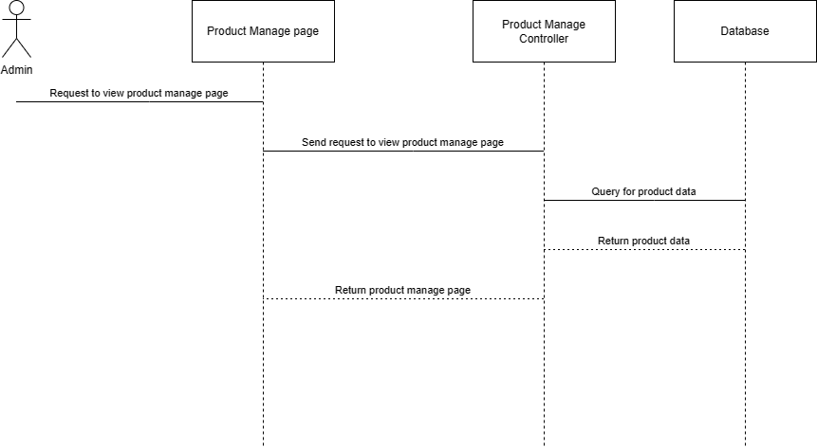

##### View product

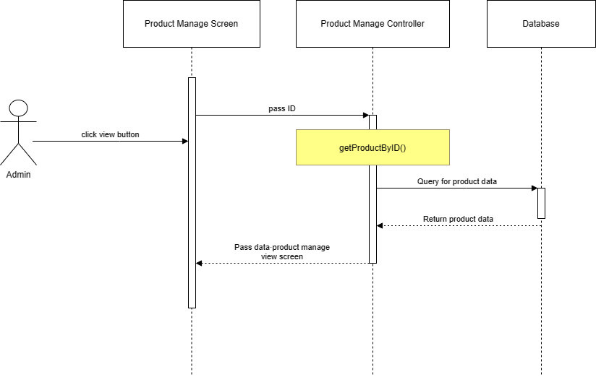

##### Add Product

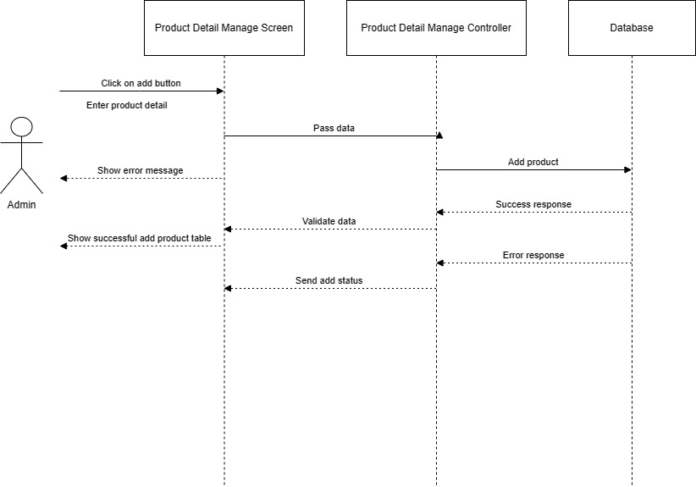

##### Edit product

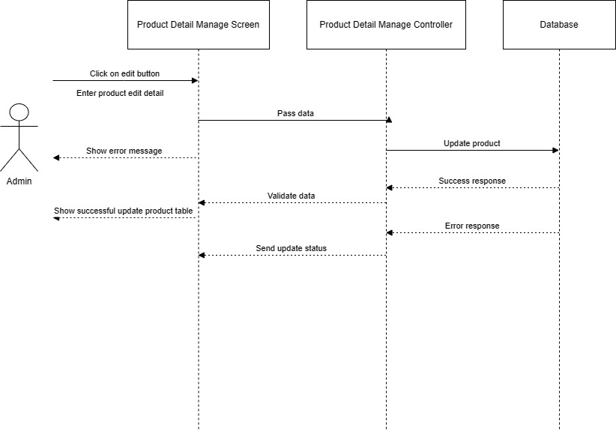

##### Search Product

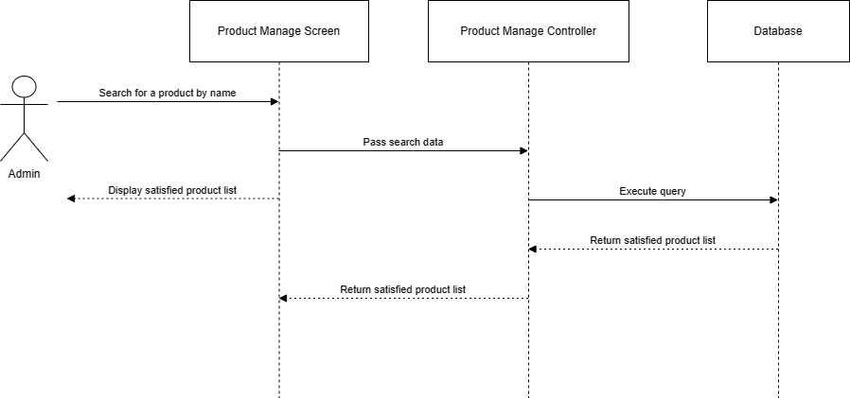

## 5. Public News

### a. Class Diagram

#### Client

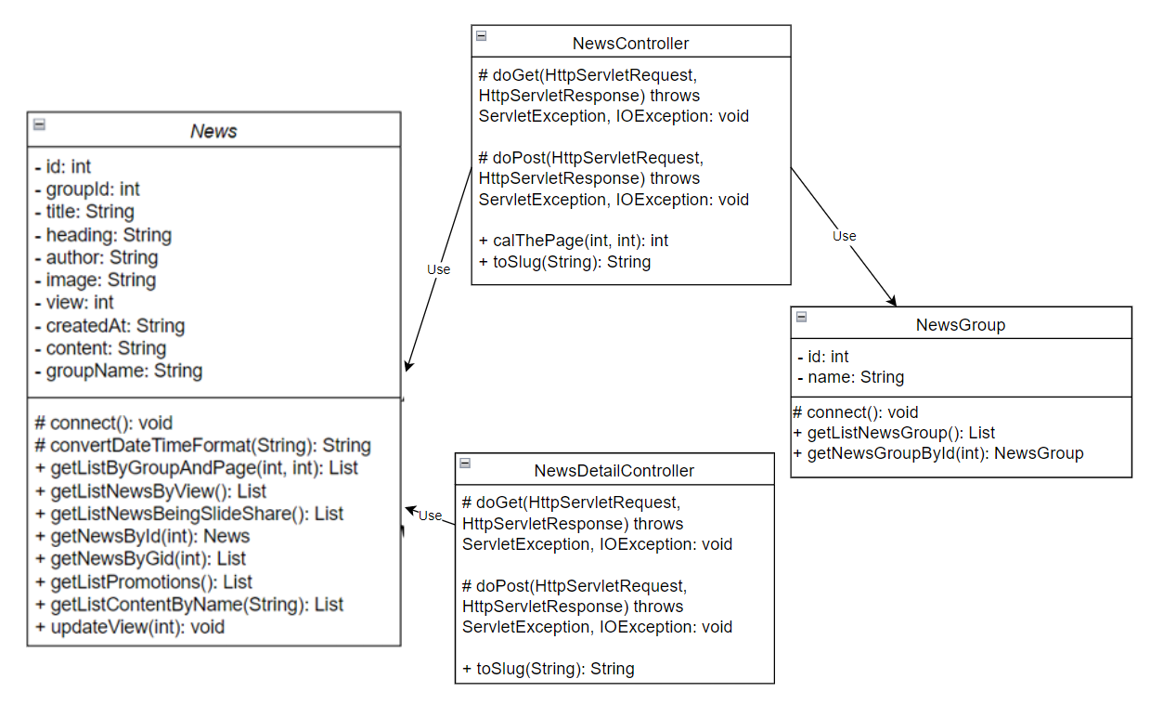

#### Admin

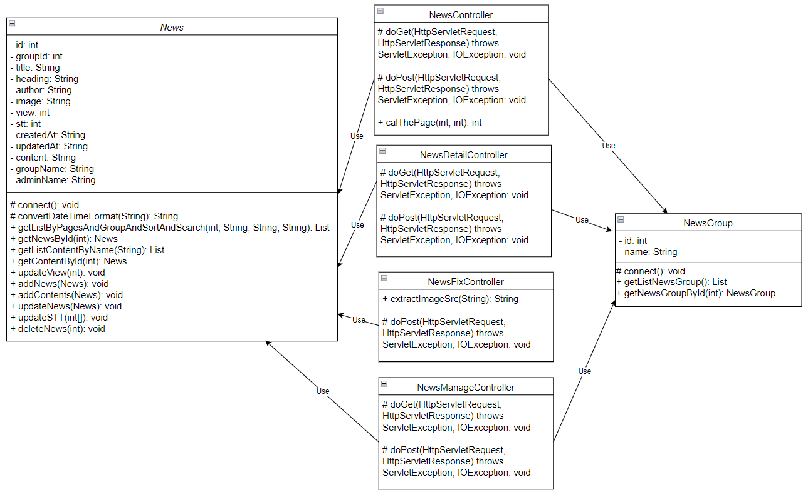

### b. Class Specifications

#### Client

##### News

|  |  |  |
| --- | --- | --- |
| **No** | **Method** | **Description** |
| 01 | public List getListByGroupAndPage(int, int) | Handle request get list of news being paginated or grouped |
| 02 | public List getListNewsByView() | Handle request get list of most viewed news |
| 03 | public List getListNewsBeingSlideShare() | Handle request get list of news being displayed on the slide banner at home page |
| 04 | public List getNewsByGid(int) | Handle request get list of news of a selected news group |
| 05 | Public News getNewsById(int) | Handle request get a selected news by id |
| 06 | public List getListPromotion() | Handle request get list of news which are categorized promotion |
| 07 | public List getListContentByName(String) | Handle request list of content by name |
| 08 | public void updateView(int) | Handle request update view of a news when click on that one |
| 09 | Private String convertDateTimeFormat(String) | Handle format the input with data type date time |

##### NewsGroup

|  |  |  |
| --- | --- | --- |
| **No** | **Method** | **Description** |
| 01 | public List getListNewsGroup() | Handle request get list of news group |
| 02 | public NewsGroup getNewsGroupById(int) | Handle request get news group by id |

##### newsController

|  |  |  |
| --- | --- | --- |
| **No** | **Method** | **Description** |
| 01 | Protected void doPost(HttpServletRequest req, HttpServletResponse resp) throws ServletException, IOException | Handle requests in POST method |
| 02 | Protected void doGet(HttpServletRequest req, HttpServletResponse resp) throws ServletException, IOException | Handle requests in GET method |
| 03 | Private int calThePage(int, int) | Handle calculation the page of the list |
| 04 | Private String toSlug(String) | Handle slug the title of the news link |

##### newsDetailController

|  |  |  |
| --- | --- | --- |
| **No** | **Method** | **Description** |
| 01 | Private String toSlug(String) | Handle slug the title of the news link |
| 02 | Protected void doGet(HttpServletRequest req, HttpServletResponse resp) throws ServletException, IOException | Handle requests in GET method |
| 03 | Protected void doPost(HttpServletRequest req, HttpServletResponse resp) throws ServletException, IOException | Handle requests in POST method |

#### Admin

##### News

|  |  |  |
| --- | --- | --- |
| **No** | **Method** | **Description** |
| 01 | getListByPagesAndGroupAndSortAndSearch (int, String, String, String) | Handle request get list of news being paginated or grouped or sorted |
| 02 | public News getNewsById(int) | Handle request get a selected news by id |
| 03 | public void addNews(News) | Handle request add a news to database |
| 04 | public void deleteNews(News) | Handle request delete a news by its id |
| 05 | public void updateNews(News) | Handle request update a news with its news attributes |
| 06 | Public void addContents(News) | Handle request add a new content |
| 07 | Public News getContentById(int) | Handle request get a selected content by id |
| 08 | public List getListContentByName(String) | Handle request list of content by name |
| 09 | public void updateSTT(int) | Handle request update order of a content when edit that one |
| 10 | Private String convertDateTimeFormat(String) | Handle format the input with data type date time |

##### NewsGroup

|  |  |  |
| --- | --- | --- |
| **No** | **Method** | **Description** |
| 01 | public List getListNewsGroup() | Handle request get list of news group |
| 02 | public NewsGroup getNewsGroupById(int) | Handle request get news group by id |

##### newsController

|  |  |  |
| --- | --- | --- |
| **No** | **Method** | **Description** |
| 01 | Protected void doPost(HttpServletRequest req, HttpServletResponse resp) throws ServletException, IOException | Handle requests in POST method |
| 02 | Protected void doGet(HttpServletRequest req, HttpServletResponse resp) throws ServletException, IOException | Handle requests in GET method |
| 03 | Private int calThePage(int, int) | Handle calculation the page of the list |

##### newsDetailController

|  |  |  |
| --- | --- | --- |
| **No** | **Method** | **Description** |
| 01 | Protected void doPost(HttpServletRequest req, HttpServletResponse resp) throws ServletException, IOException | Handle requests in POST method |
| 02 | Protected void doGet(HttpServletRequest req, HttpServletResponse resp) throws ServletException, IOException | Handle requests in GET method |

##### newsManageController

|  |  |  |
| --- | --- | --- |
| **No** | **Method** | **Description** |
| 01 | Protected void doPost(HttpServletRequest req, HttpServletResponse resp) throws ServletException, IOException | Handle requests in POST method |
| 02 | Protected void doGet(HttpServletRequest req, HttpServletResponse resp) throws ServletException, IOException | Handle requests in GET method |

##### newsFixController

|  |  |  |
| --- | --- | --- |
| **No** | **Method** | **Description** |
| 01 | Private String extractImageSrc(String) | Handle extract the source image of the news |
| 02 | Protected void doPost(HttpServletRequest req, HttpServletResponse resp) throws ServletException, IOException | Handle requests in POST method |

### c. Sequence Diagram(s)

#### Client

##### View list news

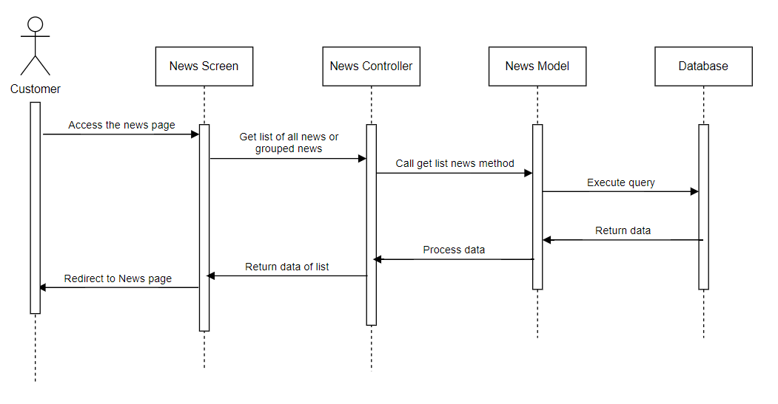

##### View news detail

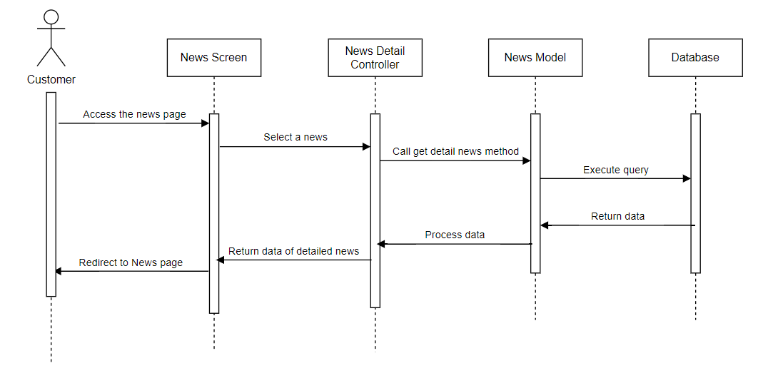

#### Admin

##### View news

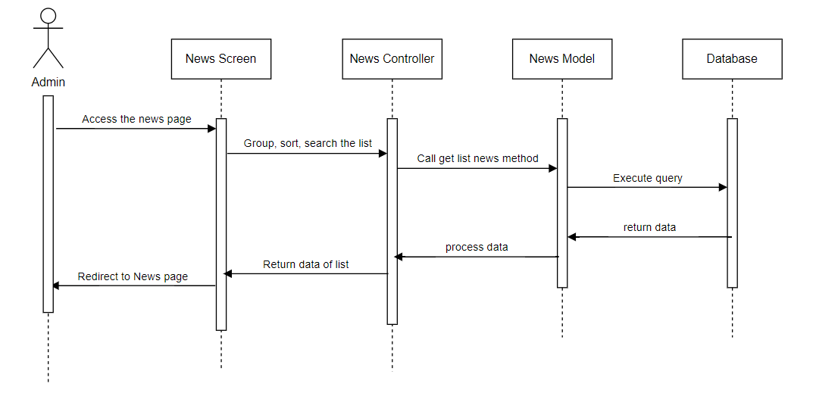

##### Add news

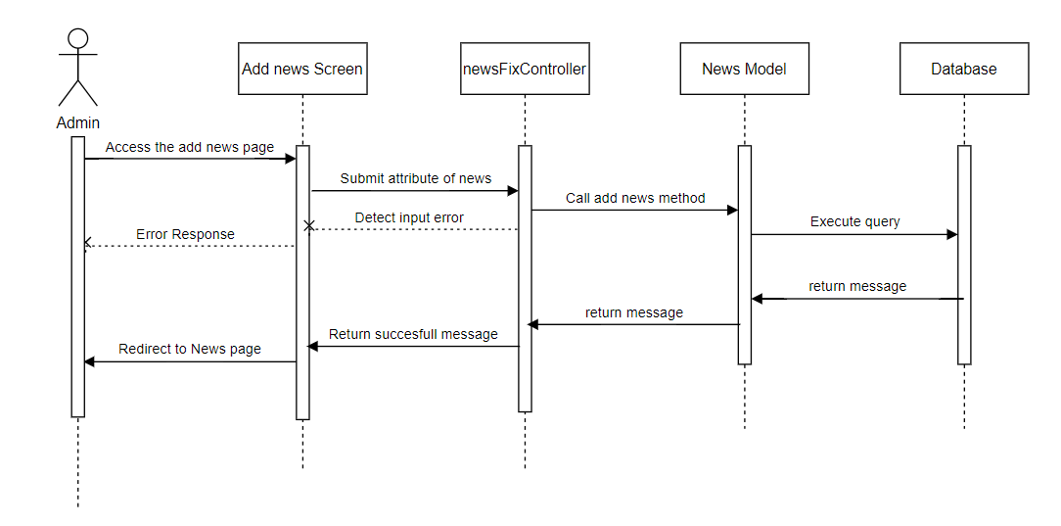

##### Update news

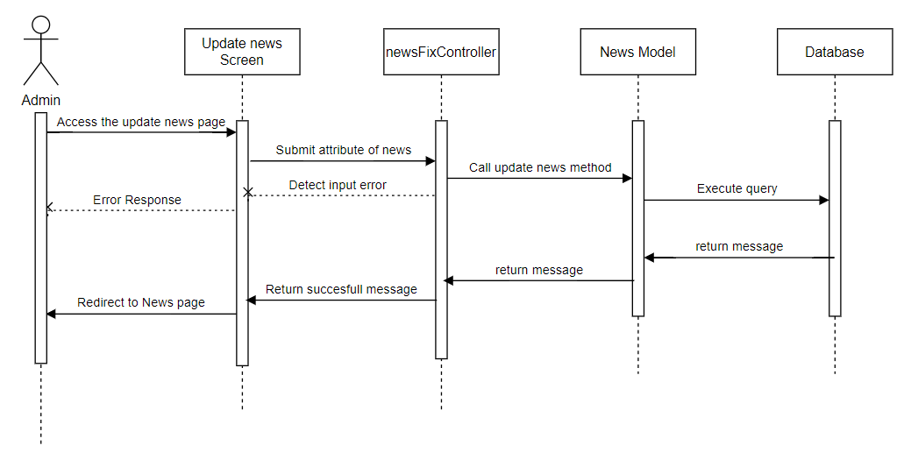

##### Delete news

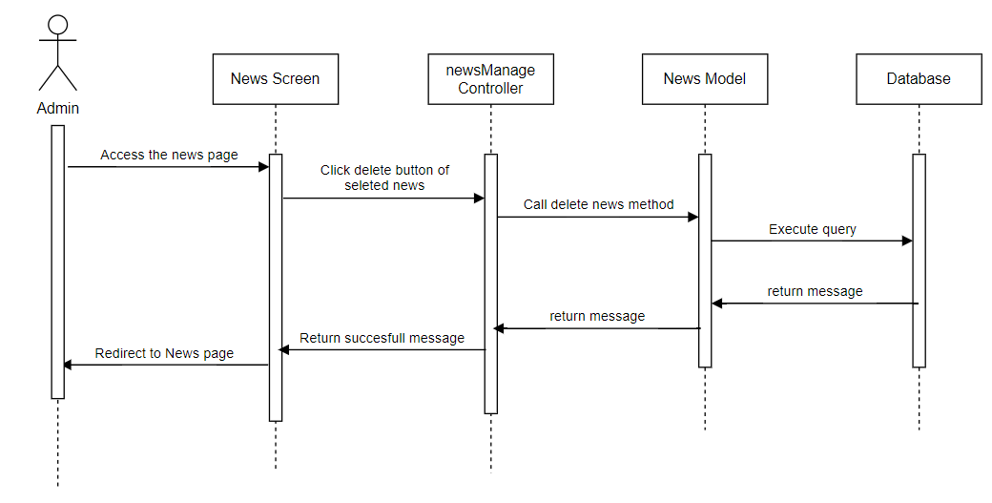

## 6. Public Category

### a. Class Diagram

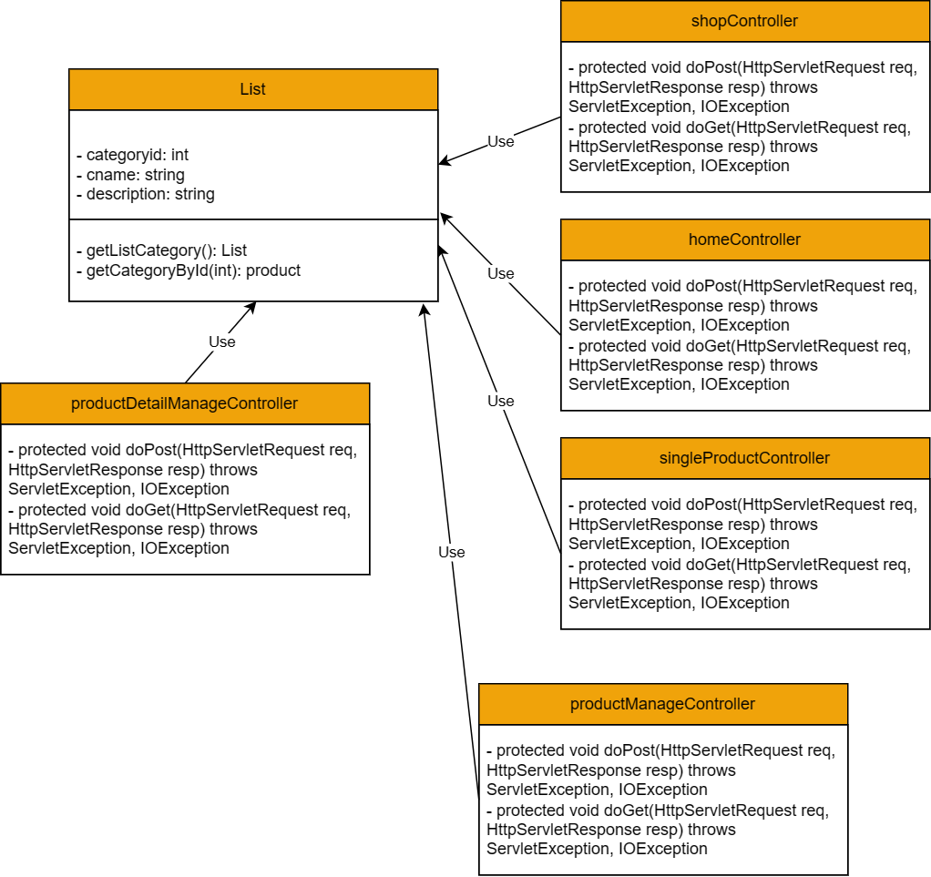

### b. Class Specifications

#### Category

|  |  |  |
| --- | --- | --- |
| **No** | **Method** | **Description** |
| 01 | public List<Category> getListCategory() | Handle request get list category |
| 02 | public Category getCategoryById(int id) | Handle request get category by ID |

#### homeController

|  |  |  |
| --- | --- | --- |
| **No** | **Method** | **Description** |
| 01 | Protected void doPost(HttpServletRequest req, HttpServletResponse resp) throws ServletException, IOException | Handle requests in POST method |
| 02 | Protected void doGet(HttpServletRequest req, HttpServletResponse resp) throws ServletException, IOException | Handle requests in GET method |

#### shopController

|  |  |  |
| --- | --- | --- |
| **No** | **Method** | **Description** |
| 01 | Protected void doPost(HttpServletRequest req, HttpServletResponse resp) throws ServletException, IOException | Handle requests in POST method |
| 02 | Protected void doGet(HttpServletRequest req, HttpServletResponse resp) throws ServletException, IOException | Handle requests in GET method |

#### singleProductController

|  |  |  |
| --- | --- | --- |
| **No** | **Method** | **Description** |
| 01 | Protected void doPost(HttpServletRequest req, HttpServletResponse resp) throws ServletException, IOException | Handle requests in POST method |
| 02 | Protected void doGet(HttpServletRequest req, HttpServletResponse resp) throws ServletException, IOException | Handle requests in GET method |

#### productManageController

|  |  |  |
| --- | --- | --- |
| **No** | **Method** | **Description** |
| 01 | Protected void doPost(HttpServletRequest req, HttpServletResponse resp) throws ServletException, IOException | Handle requests in POST method |
| 02 | Protected void doGet(HttpServletRequest req, HttpServletResponse resp) throws ServletException, IOException | Handle requests in GET method |

#### productDetailManageController

|  |  |  |
| --- | --- | --- |
| **No** | **Method** | **Description** |
| 01 | Protected void doPost(HttpServletRequest req, HttpServletResponse resp) throws ServletException, IOException | Handle requests in POST method |
| 02 | Protected void doGet(HttpServletRequest req, HttpServletResponse resp) throws ServletException, IOException | Handle requests in GET method |

### c. Sequence Diagram(s)

## 7. Public Service

### a. Class Diagram

#### Client

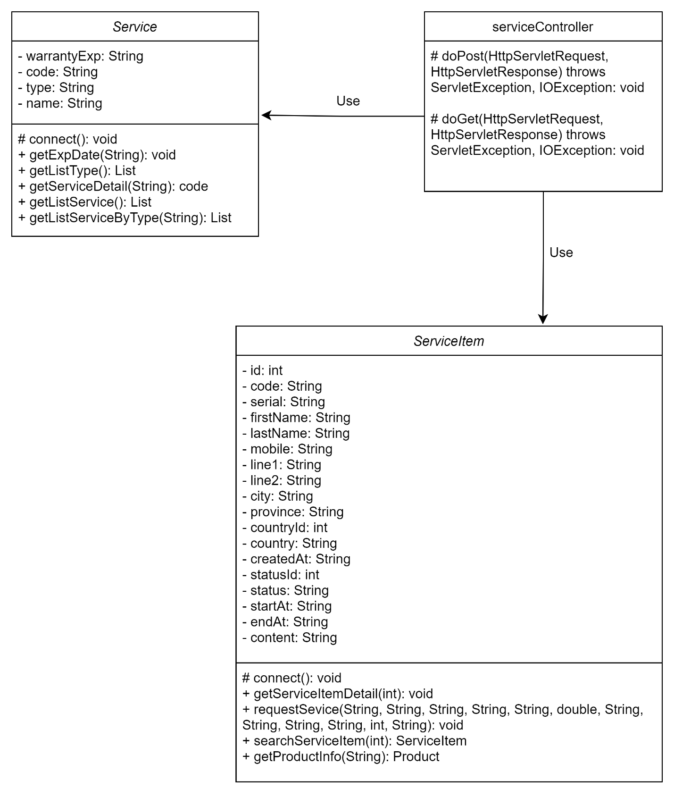

#### Admin

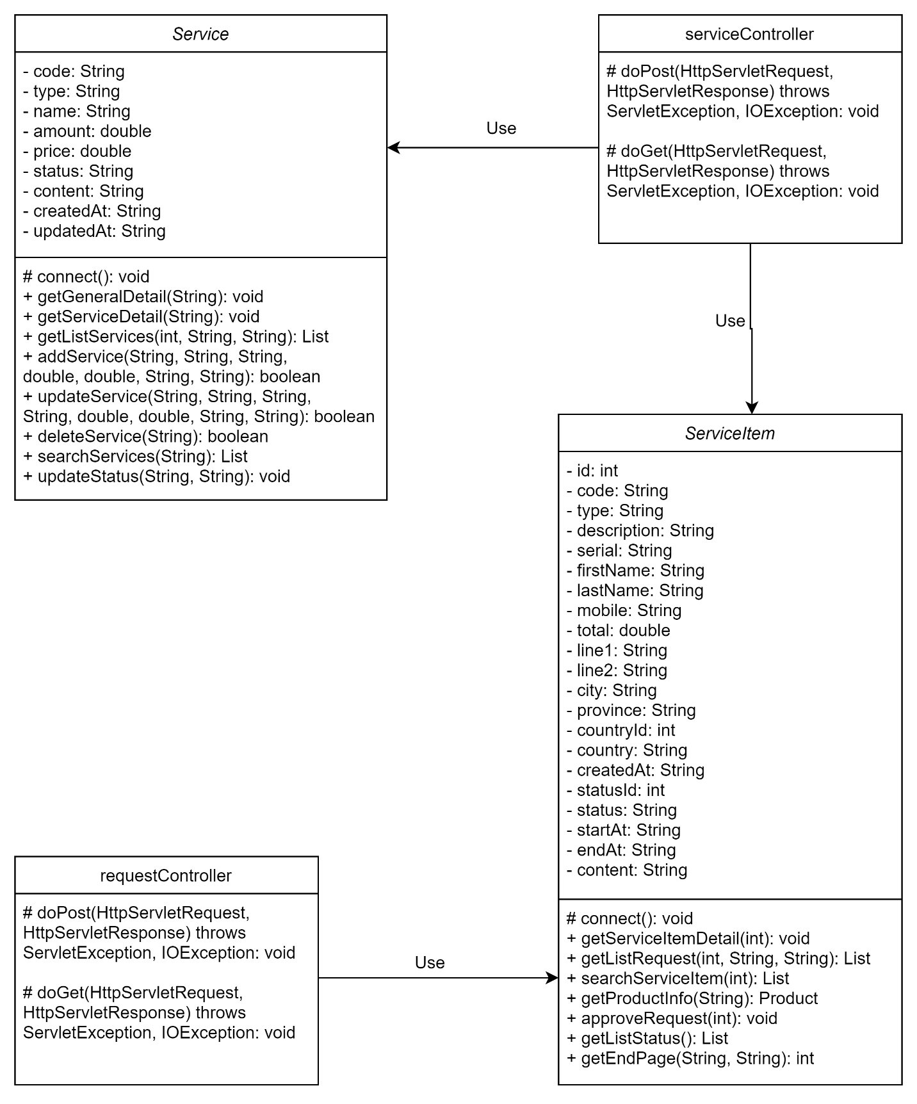

### b. Class Specifications

#### Client

##### Service

|  |  |  |
| --- | --- | --- |
| **No** | **Method** | **Description** |
| 01 | public void getServiceDetail(String) | Handle request get detail of a service |
| 02 | public List getListService() | Handle request get list of services |
| 03 | public List<Service> getListServiceByType(String) | Handle request get list of services by type |

##### ServiceItem

|  |  |  |
| --- | --- | --- |
| **No** | **Method** | **Description** |
| 01 | public void getServiceItemDetail(int) | Handle request get detail of a service item |
| 02 | public void requestSevice(String, String, String, String, String, double, String, String, String, String, int, String) | Handle request request a service |
| 03 | public ServiceItem searchServiceItem(int) | Handle request search a service item by ID |
| 04 | public Product getProductInfo(String) | Handle request get information of a product |

##### serviceController

|  |  |  |
| --- | --- | --- |
| **No** | **Method** | **Description** |
| 01 | Protected void doPost(HttpServletRequest req, HttpServletResponse resp) throws ServletException, IOException | Handle requests in POST method |
| 02 | Protected void doGet(HttpServletRequest req, HttpServletResponse resp) throws ServletException, IOException | Handle requests in GET method |

#### Admin

##### Service

|  |  |  |
| --- | --- | --- |
| **No** | **Method** | **Description** |
| 01 | public void getGeneralDetail(String) | Handle request get general information of a service |
| 02 | public void getServiceDetail(String) | Handle request get detail information of a service |
| 03 | public List getListServices(int, String, String) | Handle request get list of services |
| 04 | public boolean addService(String, String, String, double, double, String, String) | Handle request add a new service |
| 05 | public boolean updateService(String, String, String, String, double, double, String, String) | Handle request update an existing service |
| 06 | public boolean deleteService(String) | Handle request delete an existing service |
| 07 | public List searchServices(String) | Handle request search an existing service |
| 08 | public void updateStatus(String, String) | Handle request update status of a service |
| 09 | public List getListType() | Handle request get list of types |
| 10 | public List getListStatus() | Handle request get list of statuses |
| 11 | public int getEndPage(String, String) | Handle request get last page when dividing list of orders into pages |

##### ServiceItem

|  |  |  |
| --- | --- | --- |
| **No** | **Method** | **Description** |
| 01 | public void getServiceItemDetail(int) | Handle request get detail of a service item |
| 02 | public List getListServiceRequest(int, String, String) | Handle request get list of service items |
| 03 | public List searchServiceItem(int) | Handle request search a service item |
| 04 | public Product getProductInfo(String) | Handle request get information of a product |
| 05 | public void approveRequest(int) | Handle request approve a service item |
| 06 | public List getListStatus() | Handle request get list of statuses |
| 07 | public int getEndPage(String, String) | Handle request get last page when dividing list of orders into pages |

##### serviceController

|  |  |  |
| --- | --- | --- |
| **No** | **Method** | **Description** |
| 01 | Protected void doPost(HttpServletRequest req, HttpServletResponse resp) throws ServletException, IOException | Handle requests in POST method |
| 02 | Protected void doGet(HttpServletRequest req, HttpServletResponse resp) throws ServletException, IOException | Handle requests in GET method |

##### requestController

|  |  |  |
| --- | --- | --- |
| **No** | **Method** | **Description** |
| 01 | Protected void doPost(HttpServletRequest req, HttpServletResponse resp) throws ServletException, IOException | Handle requests in POST method |
| 02 | Protected void doGet(HttpServletRequest req, HttpServletResponse resp) throws ServletException, IOException | Handle requests in GET method |

### c. Sequence Diagram(s)

#### Client

##### Search warranty expiration date

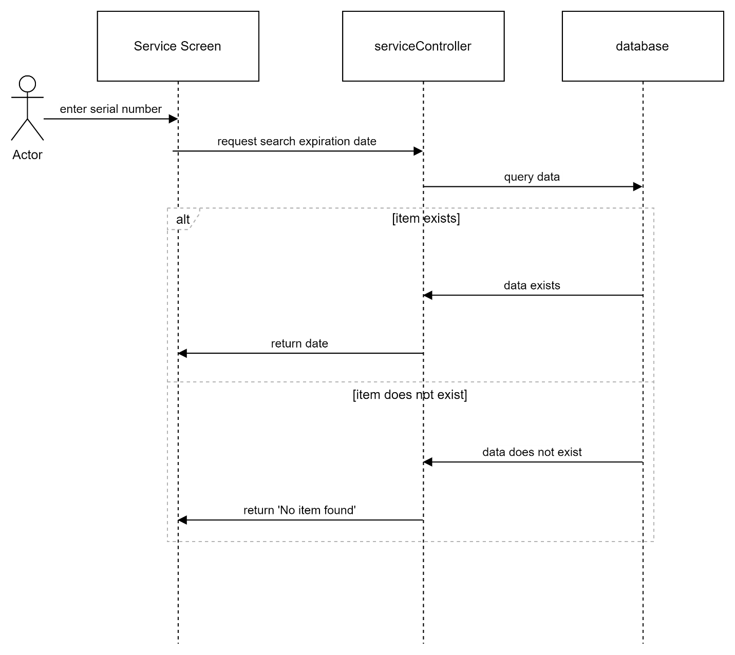

##### Request service

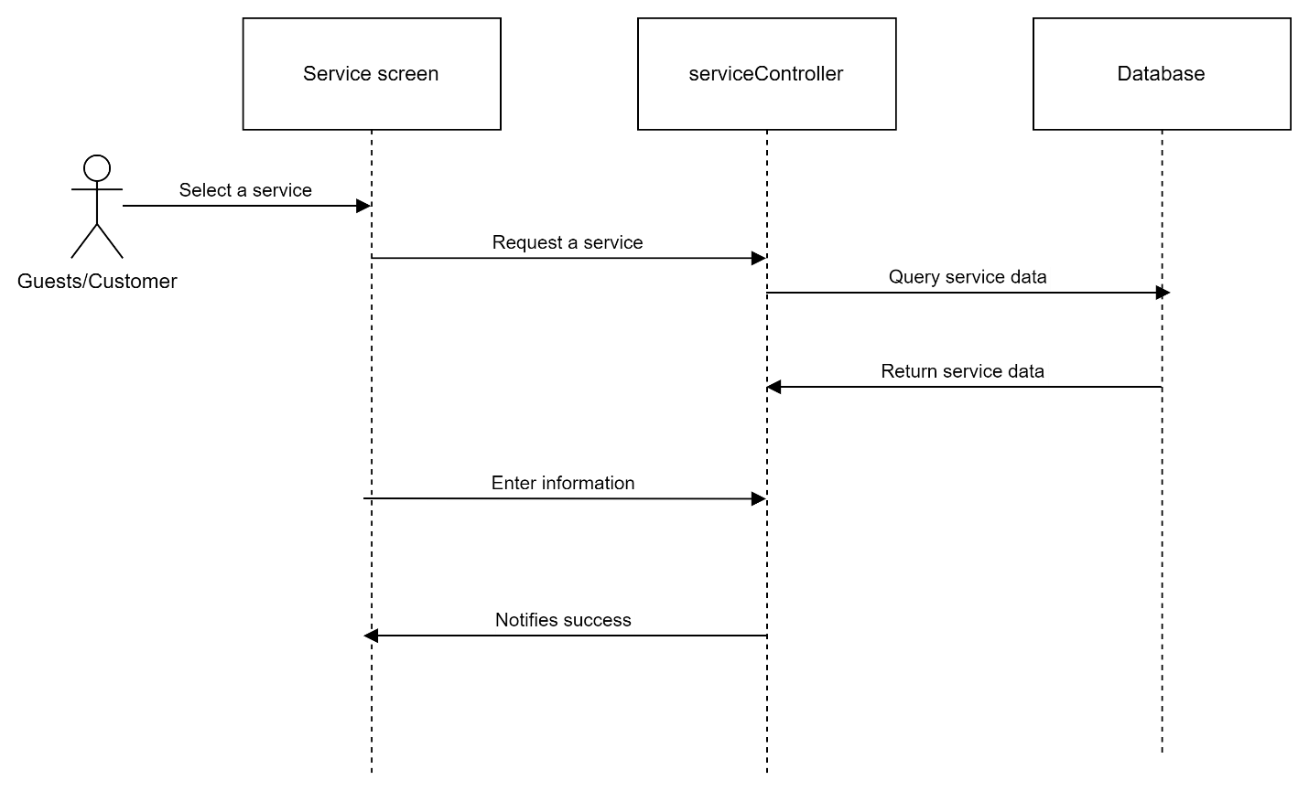

##### View service request detail

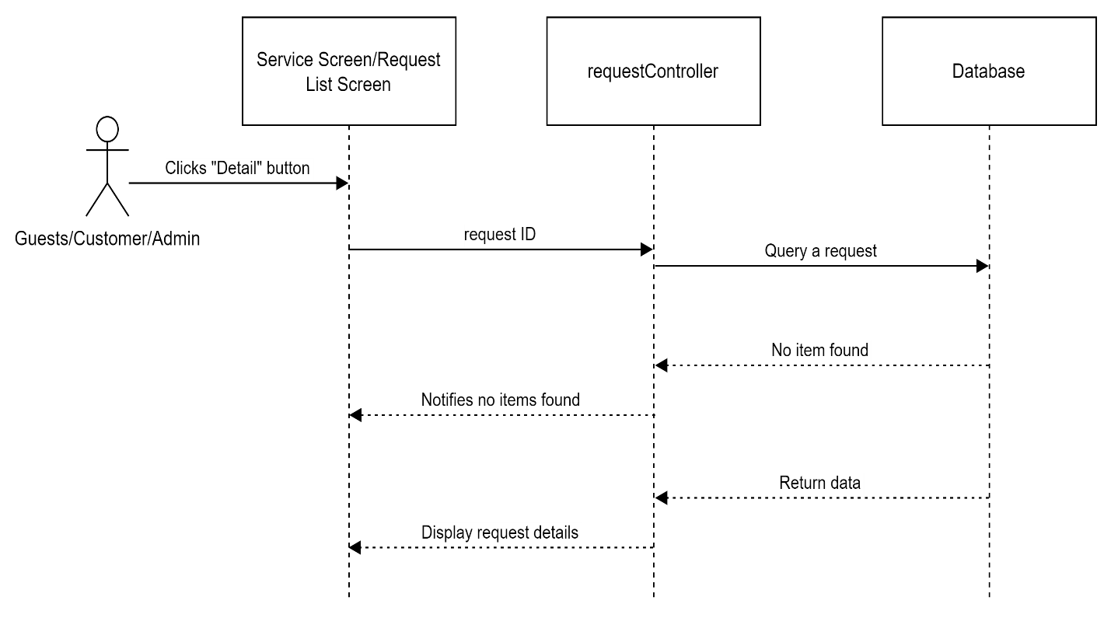

#### Admin

##### Search service request

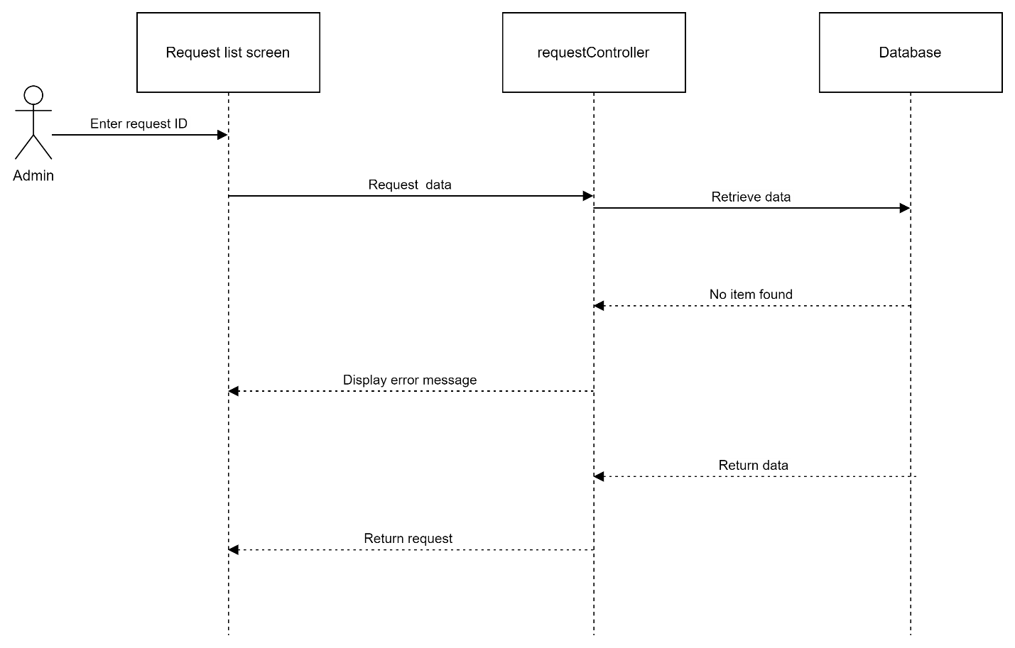

##### View list services

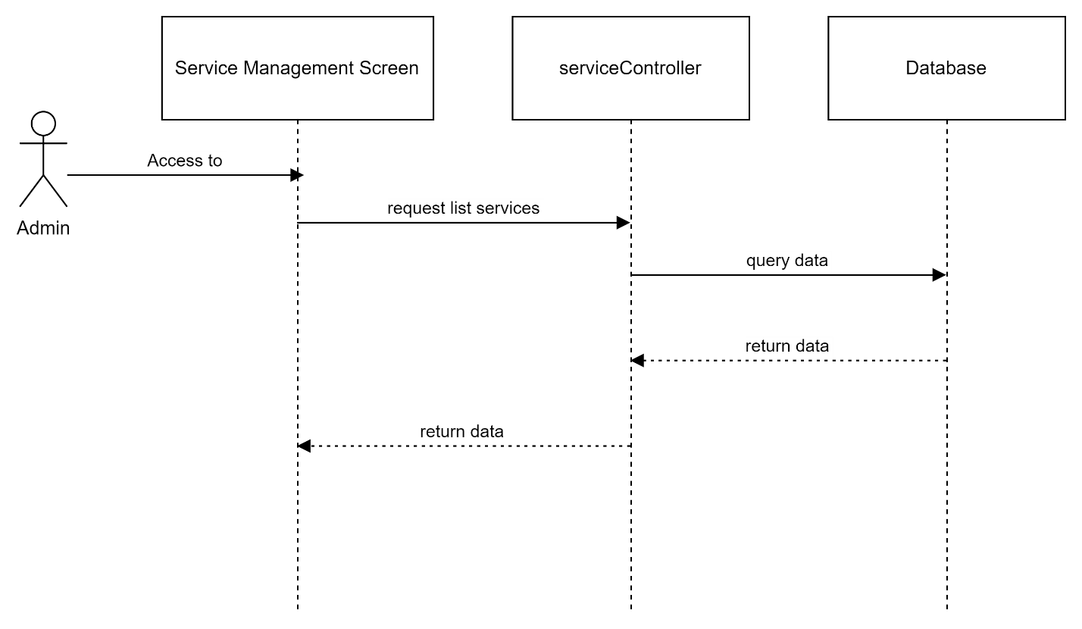

##### Modify service

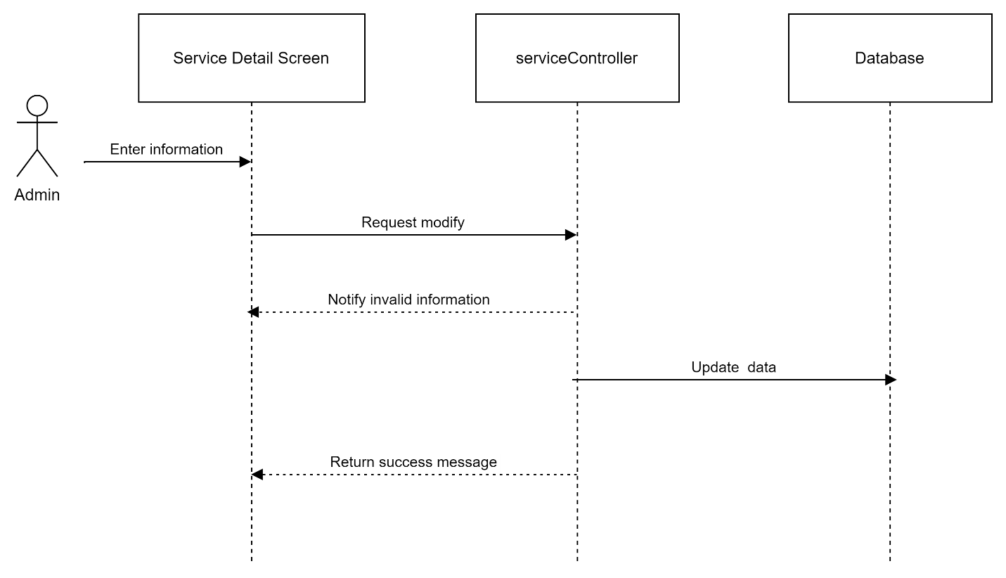

##### View service request list

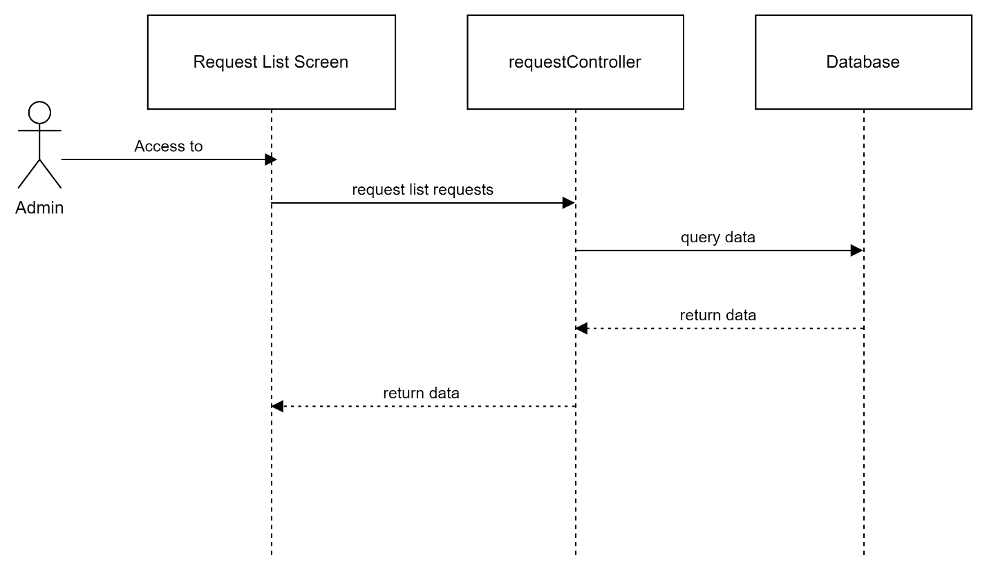

##### View service detail

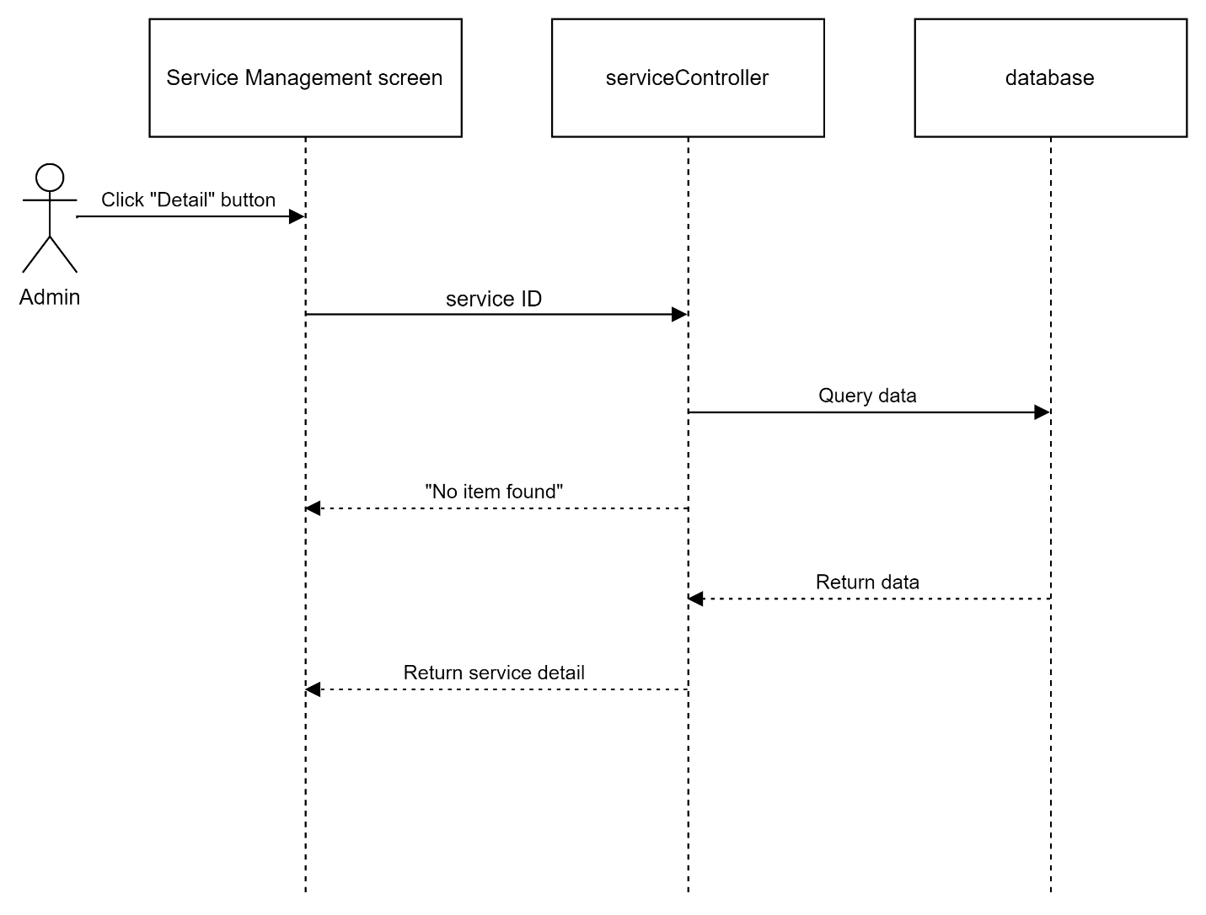

##### Update status of service request

